WG6 – Suspension Group Meeting
Meeting notes
29.01.2015 10:15 -
Michel Verkekken, Jordi Brunet, Frank Beaujean
- Conclusion of the GOCA test series
Only low correlation between all three suspension testing systems
Selection of the vehicles was not representative (mostly new cars)

- Revision of the EGEA – statement
EGEA WG6-Meeting in Paris: (Brussels 13.10.2012)
“The EGEA – proposal is as follows:
- The EGEA proposes to implement efficiency tests for class N1/M1 vehicles as a mandatory part of the PTI.
- The proposed result of the efficiency test is the physical value which is known as “Damping Ratio according to Lehr”. This ratio has no unit and shows values typically between 0 and 1.
- The proposed overall legal limit value should be (0.1).”

Discussion:
Needs to be discussed in : EGEA – proposal to agree on one hardware specification
Environment “pro suspension” testing is poor because of
the low failure rates seen in the field.
The investment costs of such kind of equipment.

The recommendation of this group is to move on with this statement as official EGEA – statement.
Decision: Final voting on the EGEA-statement in the next WG6 – Meeting

- Discussion: Follow-up investigation with GOCA on a ¼-vehicle modell
Remark: EGEA General Assembly (Brussels, 23.10.2014)
- The EGEA suspension tender needs a big budget, which is not raised yet.
- The expected result from this study is uncertain.
- The PTI-organizations (CITA) will probably not openly support the results of the study, even if it is positive for EGEA.
- EGEA’s General Assembly board advices to move the project forward by further studies, driven by GOCA.
Conclusion:
Technically it makes no or less sense to go forward with further test series at GOCA using a special ¼-vehicle test rack:
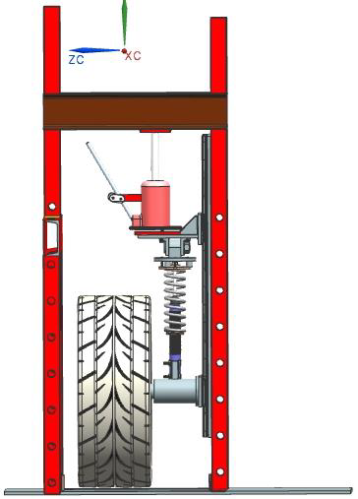
The socalled body mass (brown bar in the sketch) is practically infinitely, these is far away from any realistic situation.
We try to get in touch for more information about the test rack.
- Miscellaneous:

- Roll-up EGEA – Tender funding:
These are the known figures to support a suspension study at a appropriate vehicle institute:

AICA: 18.000€
ASA: 11.000€
AFIBA: 5.000€* (no written confirmation)

- Positionpaper for funding:
Does this exists, Yes but it is not sure if this was sent out to the member organisations (including budget plan) or to shock absorber manufacturers (FIGIEFA).

Frank Beaujean

