EGEA BEST PRACTICE GUIDELINES

Advice on how to carry out an AC service, professionally, correctly and safely
(rev2016 12 22)

1. PREFACE

The following Best Practice are intended to help those technicians who operate with Mobile Air Conditioning Equipment for HFO1234yf. Making use of them the technicians could maintain and improve their professional competence. The information is based on the technical experience of the most important Equipment Manufacturers. Some of the practices, techniques and procedures, as well as the information, tools and equipment which have been commonly used in mobile air conditioning system diagnosis and service will be different for mobile air conditioning systems using HFO1234yf.

2. DEFINITIONS

DANGEROUS AREA
Any area within or close to the equipment implying risk for the safety and health of exposed persons.

EXPOSED PERSON
Any person standing in a dangerous area.

MAINTENANCE TECHNICIAN:
- a technician trained by a service centre and authorized by the manufacturer, capable of working on the station's mechanical and electrical components, possibly by removing its covers, to make adjustments/repairs.

OPERATOR
The person/s charged with operating the machine for its intended purpose. Operators may be divided into two categories:

OPERATOR TECHNICIAN:
- Start up and monitor the station’s operation
- Carry out simple setting operations
- Remove the causes of equipment malfunctions when this does not imply repair

STATION
The piece of equipment described herein, and used to recovery, recycling, and recharge the A/C circuit

USER
Person legally responsible for the equipment.
3. R-1234yf vs. R-134a IN SERVICE OPERATION

Operators used to work with R-134a will not find significant differences when servicing an R-1234yf A/C circuit. Basically, the service procedure will be the same: recovery, recycling, vacuum, recharging. However, the operator has to be aware of these facts:

- R-1234yf is classified as a flammable substance. Refer to chapter Safety recommendations for the working environment for specific details

- A/C circuits designed for R-1234yf use specific components, including service ports and hoses. Filling an R-1234yf A/C circuit with R-134a is not legally permitted. Mixing refrigerants or using different ones may cause mechanical and/or performance problems which may affect reliability and performance of both the A/C circuit and the service station and rise warranty issues.

- When using EGEA approved equipment and following these guidelines, accidental mixing of R-1234yf and R-134a is very unlikely. However, in case of such event the resulting refrigerant must be professionally removed with a separate, recovery only equipment, and properly disposed of. Disposal shall be performed by the gas supplier or a suitable disposal facility.

4. SAFETY RECOMMENDATIONS – WORKING ENVIRONMENT

R-1234yf should be managed properly. EGEA service units are designed to handle it safely, but the working environment is important, too. Your equipment is designed to be used in a working environment where there is a minimum of one air change per hour for the entire workshop area, and at least triple air change per hour in pits.

WARNING: R1234yf vapor is heavier than air and can gather on the floor and inside pits and cause asphyxiation.
At workstations where R-1234yf is handled, both open flames and light, as well as ignition sources, such as arc welding equipment, are not permitted. Never operate the station close to heat sources or hot surfaces. The station cannot be used in potentially explosive atmospheres. Before operation, always put the station on a plane and secure position, and block it with wheel stops.
Do not expose the station to direct sunrays, heat sources, rain and jets of water.

The work area must be monitored by the operator while the equipment is operating.

As any other flammable substance in the workshop, virgin R-1234yf vessels have to be stored in a ventilated and secure place, to prevent accumulation in case of leak and formation of explosive mixture with air. The same precaution applies to storage of the station, especially for a long time (weeks or more): although an EGEA approved station guarantees a maximum leak rate of 80 g/year, this applies to new stations only; also, other factor may affect actual leak (e.g. worn out couplers and/or valves). Just make sure that the station is stored in a ventilated place, as defined before.

5. SAFETY RECOMMENDATIONS – INDIVIDUAL EQUIPMENT AND PRECAUTIONS

The operator must wear safety glasses, gloves and long sleeved protective clothing to prevent frostbites. Remember that R-1234yf boils at -30°C. Pay attention when attaching/detaching the service couplers to the A/C circuit ports, as refrigerant spray may occur.
F-Gas training and accreditation offer a good background to prevent the most common problems and lower the risks which arise when dealing with any refrigerant. As a matter of fact, R-1234yf should be handled as, if not more, carefully as R-134a to prevent chemical products escaping into the atmosphere.

Technician training is required to ensure safe, efficient and effective service and repair of mobile air conditioning systems using HFO-1234yf.
The technician must be trained to recognize which refrigerant is being handled, be trained to handle it safely and be equipped with the essential information, proper equipment and tools, which may be unique to a single refrigerant.
Technician training is required to contain and limit use of each refrigerant to vehicle requirements, to promote technician safety and minimize environmental impact using the appropriate recovery, recycling and charging equipment

6. SAFETY RECOMMENDATIONS – STATION

Only recharge the station with virgin R1234yf refrigerant. Refrain from using the station on vehicles containing other types of refrigerant. The mixture with other types of refrigerant may cause malfunctions and damages to the A/C circuit and the station.
Since some A/C circuit may contain R-134a even if equipped with R-1234yf service ports, the use of a refrigerant analyser or identifier (either stand alone or integrated into the station) is highly recommended as part of good practise.
Refer to chapter Mixed gases: what to do? For more details
Always remember that the station is designed for recovering, recycling, and recharging R-1234yf from/to automotive A/C circuits only. The station is intended to be used by automotive and similar repair and service workshops, and operated by professionally trained operators familiar with the basics of refrigeration, refrigeration systems, refrigerants and the hazards associated with pressurized equipment.
R-1234yf is flammable, but only when mixed with the right proportion of air. Because of this, when refilling the internal tank of the station with virgin refrigerant, make sure that there is no air inside, as it may happen after a repair procedure or when first filling the tank. Always follow the station manufacturer’s instruction in order to properly remove internal air.

7. MIXED GASES: what to do?

Fist of all remember that mixed gases have to be disposed of according to the current regulations. This may be expensive or impracticable, so we highly recommend to prevent gas mixtures:
- Only purchase virgin R-1234yf from reliable suppliers, and analyse it with your refrigerant identifier prior to filling the station

- Always perform refrigerant analysis before starting any service on a vehicle, even if equipped with the right service ports.

What can happen:

- Mixtures of R-1234yf and R-134a may lead to higher pressures in the A/C circuit and the station, which may cause anomalies and refrigeant leak into the environment.

- Mixtures of R-1234yf and R-134a in the station may lead to air purge system malfunctions and/or compressor failures.

- Mixtures of R-1234yf and R-134a in the station compromise the quality of all future MAC service

Remember that preserving R-1234yf purity contributes to your safety, keeps warranty conditions valid, improves your professionalism and preserved the integrity of the A/C circuit and of the station, which minimizes the overall emissions.

With these precautions, gas mixing and contamination of the station can be avoided. However, in case of contamination of the station the whole contents of the internal tank has to be recovered. Always ask the station manufacturer for assistance in order to follow the proper procedure. In general, contaminated refrigerant can be recovered into an external tank by means of a dedicated recovery only equipment. Check with your supplier if this is available in case of accident. Remember that disposal of the mixed refrigerant can be expensive, and that the station needs to be thouroghly cleaned (and some parts may need to be replaced) after a contamination.

In case the A/C circuit gets contaminated, you would need to fully recover the mixed refrigerant in the vehicle with a similar procedure, and dispose of it. As far as the vehicle, refer to the manufacturer’s specific information in this case.
For disposal of contaminated refrigerants please contact your local refrigerant supplier.
Refrigerant bottle analysis
A refrigerant bottle analysis is strongly recommended
1. to assure periodically the proper function of the refrigerant analyzer
If the bottle is original the refrigerant analyzer must detect purity of >98,5%
If the refrigerant analyzer will not detect purity >98,5% after several iterations there could be a refrigerant analyzer malfunction. Follow the unit service manual instruction for checking the identifier.

2. To avoid contamination of the internal refrigerant tank with wrong refrigerant
If the refrigerant analyzer will not detect purity >98,5% after several iterations the content of the bottle may not be filled in the internal tank of the A/C service station.

Refrigerant analysis
A refrigerant analysis before recovery of the car is strongly recommended
1. To avoid cross contamination of the internal refrigerant tank with wrong refrigerant
2. To avoid contamination of further cars
3. To protect your workshop in cases of accusations of contamination
Incorrect refrigerants can damage parts of the A/C system and can be explosive!

Cross contamination of refrigerant and oil
An oil cross contamination of max. 0,1% by weight must be observed (according to SAE J 2843 §8.9.5)
Reason: For electrical compressors the use of POE oil (low electrical conductivity) is usually required. A contamination with > 0,1% by weight of PAG oil (higher electrical conductivity) can cause serious damages of the compressor.
A flushing cycle with refrigerant is required to clean all oil wetted parts to assure the required purity of the oil added.

Manual oil filling process
In case of not automatic oil filling the knowledge of the extracted quantity of oil is essential.
If the A/C service station not provides an indication of the drained oil, the quantity must be determined manually with an external measuring device.
The determined quantity of the drained oil must be filled with the A/C service station or with an external oil filling equipment

8. HOW MUCH R-1234yf HAS TO BE FILLED IN?

If your EGEA-compliant station comes with an integrated vehicle database, this can be the source. However, always check for the presence of the information label (see picture), and/or read the car maintenance manual, which always contains the most reliable information.
Stations complying with EGEA specifications guarantee state-of-the-art accuracy in both recovering and recharging. Always keep this accuracy in mind when servicing an A/C circuit before coming to any conclusion. For example (worst case):
- When filling an A/C circuit with nominal capacity of 500 g, the actual charged quantity may be as low as 485 g due to the filling accuracy of +/- 15g.
- If you recover the refrigerant from the same car after some time, remember that the station recovers a minimum 95%, which means 460 g (minimum); however, recovery accuracy is still +/-30 g: the displayed quantity may be as low as 430 g
Appropriate training is essential in order to understand these “subtle” issues and to prevent unnecessary operations (for example, searching for a leak when there is no leak at all)

9. WHICH OIL TYPE (PAG/POE - viscosity)?

Supply of correct oil type (viscosity and conductivity) is essential to preserve A/C circuit performance. EGEA stations equipped with automatic oil injection have storage bottle which prevent any contact with atmospheric moisture, which is the most damaging pollutant. Water in the A/C circuit may result in ice formation which may significantly alter the A/C circuit characteristics; When using highly hygroscopic oils, they tend to absorb atmospheric moisture. If your station is equipped with refillable oil bottles, always fill them with oil from fleshly opened sealed containers.

The correct type of oil to be used is specific to each A/C circuit. Always refer the vehicle manufacturer’s documentation. EGEA stations provide means a solution to prevent oil cross contamination when switching between different oil types. It is essential to use different new oil bottles for different oil types, especially as far as PAG and POE are concerned. Always follow the station manufacturer’s instructions to properly clean the station when switching between two different oil types (hoses and internal flushing procedure).

Usage of UV dye.

Minimum spec of UV dye needs to be defined and reason for use as preventative maintenance on older vehicles

The fluorescent leak test method is based on the injection in the A/C of a liquid tracer commonly called UV dye. This substance is composed of chromophore (the colour), of lube oil, solvent that allow the mixture of previous two components. The quality and quantity of any of these three substances will be index for the UV dye quality. Bad quality UV dyes own low concentration of chromophore and high concentration of solvents, the last one in particular affects the lubricant power and viscosity of the compressors oil with wear and tear consequences, moreover it penetrates deeply inside the rubber sealings altering their properties.
The conformity to the norm SAE J2297 grant good quality of the UV dye, ever verify on the data sheet.
But how practically recognize high quality in the UV dyes?
- If the substance strongly smells of naphthalene has low quality.
- Doubt of UV dyes highly fluorescent when in drops or still inside the bottle, it is index of low concentration of chromophore. The UV dye must be highly fluorescent only when reduced in thin film.
- “Thin film” method, place a single UV dye drop between two slides (as alternative spread the drop on a wide flat surface) and verify its florescence using an appropriate lamp. Ever check that UV dye and lamp have the same spectrum light frequency.
The European F-gas norms forbids to refill with refrigerant a leaking A/C plant if not previously repaired, indeed it is very important that the A/C is already filled with UV dye before a leak occurs. It is so recommended to inject the UV dye ( in the quantity suggested by the UV dye manufacturer) at every service as long as it has a good quality. A small overabundance of good quality UV dye would not cause any defectiveness to the A/C, in a different way the usage of a poor quality UV dye will reduce the life of the A/C.

Recommendation for the Supply of UV additive:

The UV additive must be supplied into the hermetically sealed UV additive storage bottle on the service unit directly from closed containers (storage containers).
The UV dye is available at different concentrations or pure (even if in second case it is ever mixed with oil and solvents). The oil mixed with the UV, if some measures are not taken, can represent a real enemy for the life of the A/C. The oil mixed with the UV dye must ever be of the same type already present in the A/C (proper PAG for R134a, proper PAG for R1234yf, POE for electrical driven compressors)! Moreover it is important to avoid contact between air moisture and oil/UV dye because they are substances highly hygroscopic. Any moisture absorbed by the oil and UV dye would be then injected in the A/C causing ice obstructions in the expansion valve, damages at the compressor’s valves and creating acids that bring to decrease the refrigerant performances.
It is so ever suggested to follow these measures: do not leave the recovery station oil/UV dye containers or the oil /UV dye brand new tanks opened at the air, prefer recovery stations that allow the use of sealed oil/UV dye containers.

11. HOW TO IDENTIFY AN EGEA STATION FOR R-1234yf

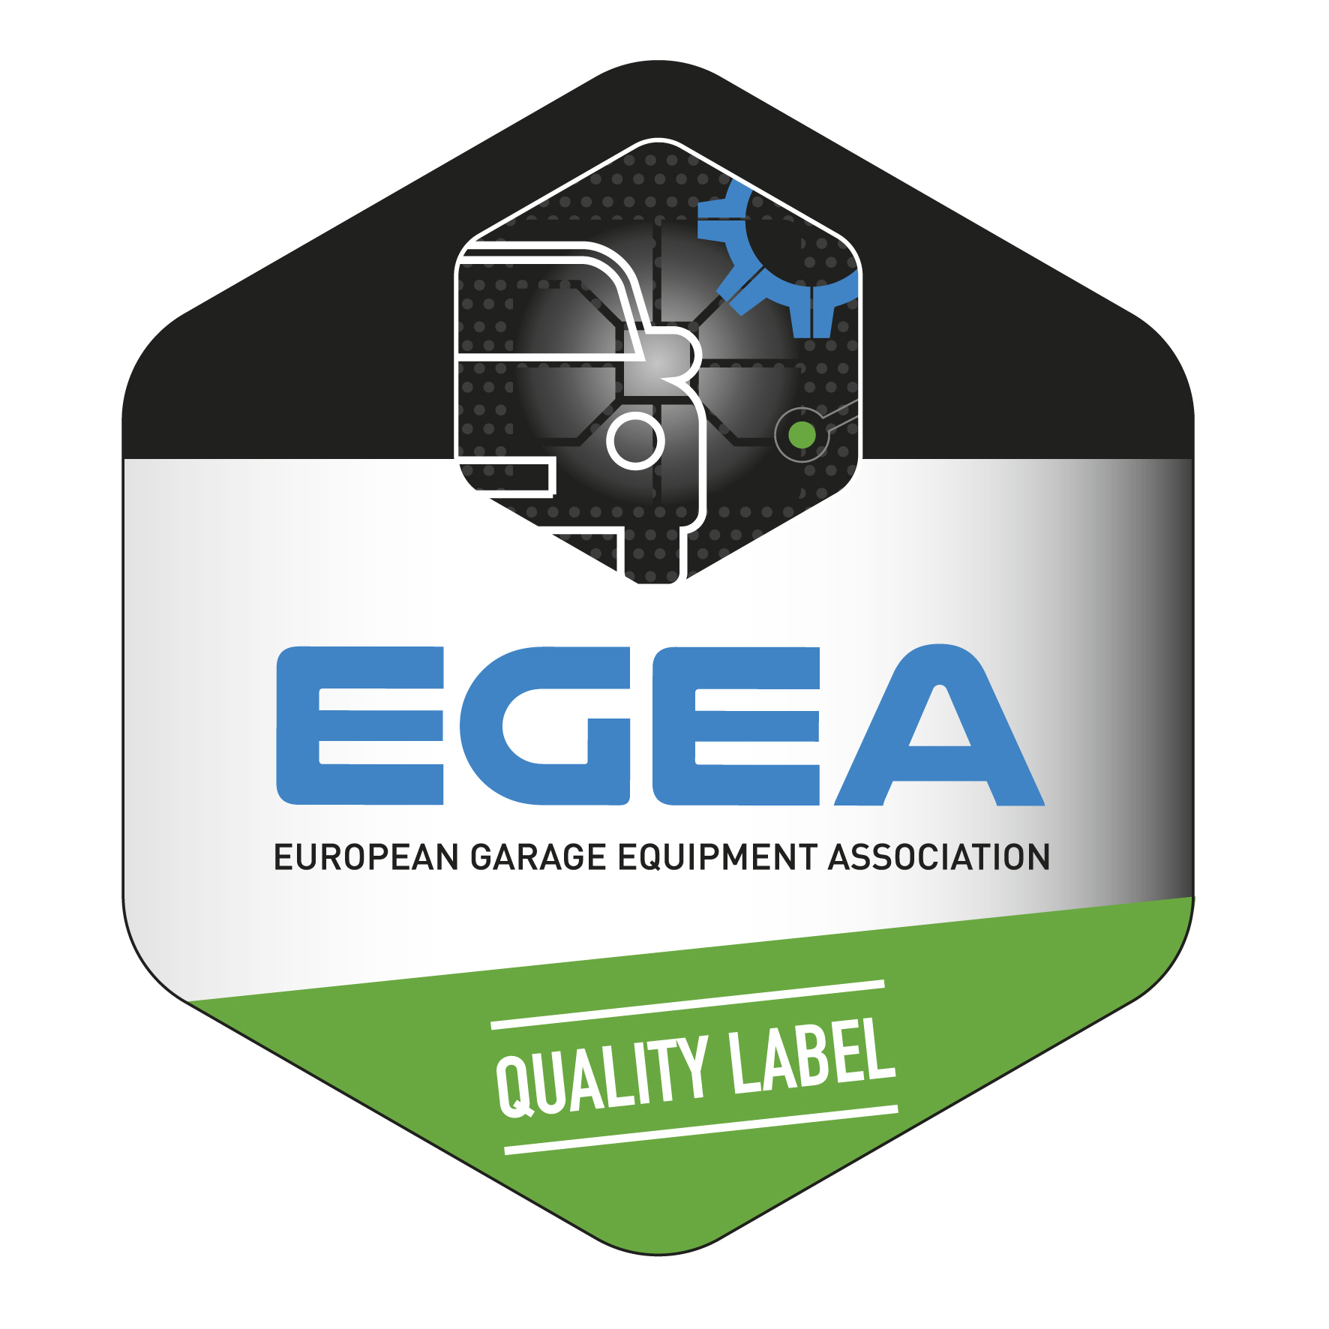

The operator is responsible for operating the station in conformity with local legislation. The minimum requirement in the EU is compliance with the PED (Pressure Equipment Directive 97/23/EC). This is certified by both the EGEA logo and the reference to the Directive and the notified body certifying the station’s compliance to the Directive.

12. PROPER MAINTENANCE OF YOUR STATION

First of all, carefully read the user’s manual and follow the instructions on the station’s display. Particular attention should be given to the following:

- Dryer filter replacement: a filter which saturated its acid capacity does not guarantee a proper acid absorption: the recovered refrigerant cannot be purified at the specified level

- Vacuum pump oil replacement: remember that a worn out oil lowers the pump efficacy (less vacuum, partial dehumidification of the A/C circuit)

- A/C station should only be serviced by a trained operator or by the manufacturer’s authorized service center. Be aware that improper operation may affect the safety characteristics of the station.

Replacement of filters is important due to machine serviceability, warranty, accuracy and purity considerations

Filter-driers are a key component in any system which use the refrigerant for its work.
Filter-driers in those kind of systems play two pivotal roles, which are:
• Absorption of moisture/water from the system which can create harmful acids and/or ice formations.
• Physical filtration of solid contaminations, particles, chips etc.

Absorption of moisture is made by a desiccant which is a special chemical material or substance. The role of desiccant is to stop water molecules during the flow of refrigerant through the filter drying out the system from moisture.

The physical filtration which stops particles present in refrigerant is accomplished by different solutions. The most simple method is screen filter which is most often woven wire mesh which catches solid molecules larger than the holes in the mesh. Another method is fiber glass pad in the filter compartment. Those methods can work also simultaneously as a combined solution of physical filtration.

Air-Conditioning service machine is a kind of system using refrigerant. That why the filter-dryer is so important for proper working of the unit. Most of the AC machines perform three general functions: recovery, recycling and recharge of refrigerant (RRR). The unit recover the refrigerant from car AC system which can have moisture or/and particles. That is the reason of installing filter-drier in service machines. The refrigerant after the recycling (filtering) process goes directly through valve block to internal storage vessel where is mixed with pure refrigerant. After the refrigerant is used for recharge and is has to be pure without moisture and physical contamination. Solid particles inside the AC service unit system can cause valves blocking and as a consequence improper working of the unit. Moisture inside the system can cause ice formation and acids which cause corrosion of metal parts and degradation of seals.
Each machine is designed and tested for work with one exact type of filter-drier and that why you have to use always only recommended filters by the manufacturer of AC service unit. Using only recommended spare parts guarantees the working accuracy and serviceability of the machine.
Each type of filter-dryer has its own capacity of moisture which can be absorbed by the desiccant. If the filter reaches his capacity it has to be replaced by the same but new one. Only than you can be sure the machine will work with nominal parameters.
Almost each automatic RRR machine has internal counter which informs the user about the necessity of filter-dryer replacement. Replacement of filter without any delay could be an issue also in case of eventually warranty claims. That why a good practice is to have always the new spare filter-dryer with the machine.
When changing the filter pay attention to maintain the system opened as short as possible. Before assemble the new filter grease its o-rings with AC systems lubricant and make sure they are correctly located in the grooves.

***

