EGEA Specifications
Service Unit for MAC Systems

For use with Motor Vehicles using

Refrigerant R-1234yf
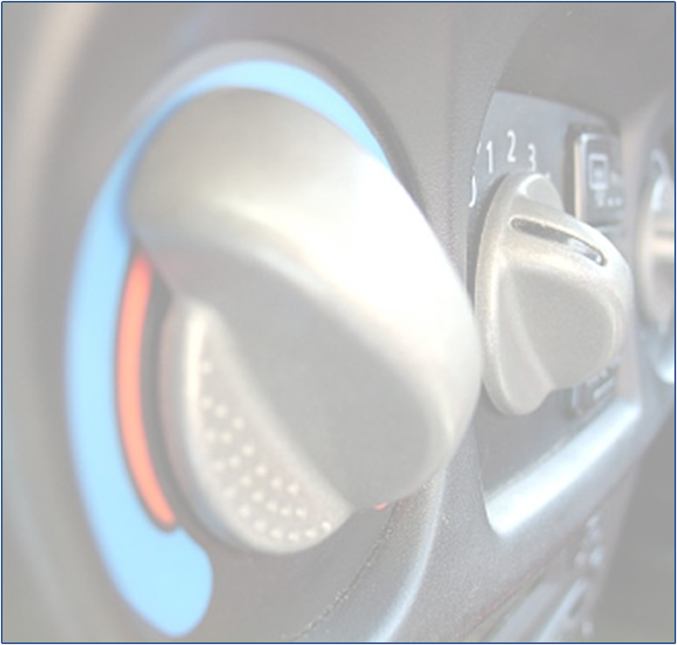

Contents
1. Introduction 3
2. Scope 3
3. Requirements on the Service Unit 3
4. Approval Requirements. 3
5. Operating Conditions 3
5.1 Temperatures 4
6. Safety Concept and Risk Assessment 4
7. Technical Specifications and Basic Scope of Delivery 5
7.1 Service hoses 5
7.2 Service couplings 5
7.3 Display of process fluids quantities 5
7.4 Refilling 5
7.5 Emptying and Filling Process 5
7.6 Precision of the Evacuation Process 5
7.7 Vacuum Test 5
7.8 High/ Low side measurements 5
7.9 Filling Precision 5
7.10 Supply of Fresh Refrigerant Oil and UV Dye 6
7.11 Evacuation of the Service Hoses 6
7.12 Refrigerant Purity 6
7.13 Filter Inserts 7
7.14 Leakage Rate 7
7.15 Requirements for Non-Condensable Gases (NCG’s) 7
8. Technical Requirements Optional Scope of Delivery (Equipment Version Specific) 8
8.1 Refrigerant Quantities Database 8
9. Test Specifications 8
9.1 Filling Precision / Precision of Evacuation 8
9.2 Maximum refrigerant oil discharge during evacuation 10
9.3 Scale accuracy reliability. 10
10. General Service Documentation 10
10.1 Compliance Statement 10
10.2 Risk assessment 10
10.3 Test results 11
10.4 Accompanying Documentation 11
11. Appendix 1 12

Introduction
This specification has been written with the intention of defining the operation of an AC Service stations for use with refrigerant HFO 1234yf. A unit that is designed and conceived using this specification will fulfil all legal requirements and allow manufacturers the design and engineering solution freedom.

Scope
The scope of this document is to assist in the design and conception of a EGEA specification compliant HFO1234yf AC Service Station. It sets out the specifications that such a unit needs to meet in order to supply a safe and reliable unit to operators.

Requirements on the Service Unit
The service unit must comply with the specific national laws and legal provisions and requirements. These can also comprise regulations about the handling of refrigerants and their respective storage bottles. The service unit, including all of its respective equipment and related documentation, must meet the legal regulations, ordinances, prescriptions and directives valid in the respective country at the moment of ordering. The manufacturer must provide to the independent and accredited test institute documented evidence of the product's compliance with all the legal provisions of the EU valid for this kind of product.

The manufacturer must also supply the compliance statement, the R-1234yf-related risk assessment, the certificates and the operating instructions according to the relevant legal provisions.

This does not affect further obligations according to the respective national legislation, as for example national machine safety laws, or national laws about electromagnetic compatibility, in any way.

Approval Requirements.
The "EGEA label" license can be only granted by EGEA to manufacturers whose products comply with this EGEA specification and all the directives listed herein, namely the EMC Directive 2004/108/EC, the LVD (Low Voltage Directive) 2006/95/EC.

Compliance to any of these directives has to be proven.

Compliance to the EGEA specification (functional performance, reliability, design issues, etc.) shall be checked and properly documented by a Notified Body that can also evaluate the conformity to PED (Pressure Equipment Directive) 97/23/EC; required tests can be performed at any location, either at the equipment manufacturer's facility or other laboratory.

The report shall be signed by the Notified Body's delegate, and any change to the design of the unit (accessories etc such as a printer or color or brand, are excluded), which may or may not affect its performance, has to be submitted to the Notified Body, which evaluates the need for further and/or additional tests.
Any review of the reports shall be submitted to EGEA for labeling permission renewal

Operating Conditions
All components of the service unit must be able to resist all environmental and climate influences occurring during operation of the equipment (service unit on), and standstill (service unit off) within a vehicle repair workshop environment, and must be corrosion-resistant. This also implies mechanical, chemical and thermal stress.

Temperatures
Environmental temperatures in the workshop
(Service unit operating temperature range)
Minimum environmental temperature: + 15 ºC
Maximum environmental temperature: + 45 ºC

Storage temperatures
Minimum environmental temperature: - 10 ºC
Maximum environmental temperature: +50 ºC

Safety Concept and Risk Assessment
At initial power-up the fan shall be operated long enough to perform one air change prior to any other operation.

When the unit is powered, it shall be ensured that there are at least 6 air-exchanges per hour to prevent build-up of concentration of vapour of the enclosure of the cabinet.

If the air-flow is not detected, then it shall be ensured that the operation of the unit will automatically stop.

Electric devices (e.g fan, switch, etc) shall avoid the generation of sparks if fitted within the cabinet.

The use of a refrigerant identifier is optional.

After switch-on, the service unit should indicate to the operator when the machine is ready and prevent operation during this period.

In case of a malfunction, shut-off valve(s) installed must close automatically to prevent excessive refrigerant loss from the refrigerant tank..

If the unit is accessible without the need of tools, then the unit must be automatically isolated and stopped. Adequate and appropriate labelling should indicate internal hazards should a cover be removed.

For oil and/or filter replacements, an automated maintenance mode must be implemented. This is to ensure that refrigerant loss is minimised and thereby the potential of a flammable atmosphere is reduced to a negligible level.

All the individual components of the service unit must be replaceable as spare parts.

A high-pressure interruption switch shall also be used to ensure that unnecessary discharge of refrigerant through the overpressure relief valve is prevented in case of increased system pressure in the service unit.

The scale calibration must be maintained even though the machine is moved within the working workshop environment.

Test to be done according to chapter 9 of this document.
The service unit must be capable of producing a service report including at least refrigerant and oil quantities (recovered and refilled).

Technical Specifications and Basic Scope of Delivery

Service hoses
The service hoses and thread connections for the refrigerant R-1234yf must be manufactured according to the standard SAE J2888.

Service couplings
The service couplings for the high and low side with integrated block valves must meet the standards SAE J2888 and J639.

Display of process fluids quantities
The process fluids quantities in the service unit must be displayed before the service unit starts to work.

Refilling
Refilling of an AC system of a motor vehicle is not allowed when a positive pressure exists within the vehicle system.

Emptying and Filling Process
After use, the unit evacuates the service and internal conduits of the unit automatically. The refrigerant that was extracted from the conduits must be returned to the internal refrigerant storage bottle

Precision of the Evacuation Process
The unit shall be capable of recovering a minimum of 95% of the refrigerant present in the test conditions in Chapter 9.
The recovered refrigerant quantity shall be displayed with a tolerance of ± 30 g (see Annex I for the performance test conditions)
At the end of the evacuation process, the simultaneously extracted oil shall be automatically drained into a respective storage bottle with a precision of ± 5 g or 5 ml.
After the evacuation process, the quantity of the refrigerant oil that was extracted along with the refrigerant must be visible on the display.

Vacuum Test
The vacuum pump must be capable of creating a minimum pressure of 5 mbar in 10 minutes when connected to a test cylinder of 2 litres.
The vacuum test is performed as follows: 150 mbar maximum vacuum decay for at least 3 minutes, according to SAE J2843. The sensor must operate with an accuracy of +/- 15 mbar.
This shall be documented in the sample inspection and must be securely complied with in the scope of serial production inspections.

High/ Low side measurements
The performance and accuracy of the pressure sensors must comply with EN 837, class 1 or better; maximum full scale is 60 bars.
Analogue Gauges (not mandatory) must comply with EN837, class 1.6 or better.

Filling Precision
The filling precision for the refrigerant, fresh oil and UV additive must be guaranteed for the whole specified temperature range
The refrigerant quantities shall be charged through the service couplings in doses with a precision of ± 15 g.

Supply of Fresh Refrigerant Oil and UV Dye
If Oil & UV additive are injected automatically by the machine then the filling precision is ± 5 g/ 5ml.

If storage bottles for oil are fitted, then they shall all be labelled in such a way that it can be clearly distinguished between oil types and specification and from the storage bottle for used oil.

Cross contamination between higher and lower conductance oils should be limited and comply with the requirements of SAE J2843.

The supply of fresh refrigerant oil shall be achieved in such a way that it is ‘moisture free’ in the vehicle. If a storage bottle is used, it should be designed in such a way that prevents any contamination from moisture.

If the unit is capable of providing automatic oil refilling of the vehicle system, then the unit must always refill the vehicle system with the same quantity of fresh oil corresponding to the quantity of recovered oil.

If the UV additive is injected automatically, the following should apply:

The UV additive must be stored in a separate, hermetically closed container on the service unit.

The filling quantity of the UV additive can be weighed by means of a scale or be dosed with the help of a time-controlled valve.

The supply of this fluid must be optional, i.e. a new charging must also be possible without the supply of UV additive.

Evacuation of the Service Hoses
After the refilling process, the service unit must automatically evacuate its internal conduits and pass the refrigerant into an internal storage bottle.

The connection of the service couplings to the vehicle must be de-pressurised, i.e. there must be no overpressure in the service couplings.

The service hoses shall be empty (below atmospheric pressure) at the end of each service operation and before any new service starts.

If the service unit could not be switched off in a regular way due to a voltage breakdown or other reasons and the selected procedure could not be completed correctly, the service unit must automatically switch into its basic state (e.g. non pressurized fill hoses) during restart.

Refrigerant Purity
The following indications on refrigerant purity are subject to pending examinations. The values may still have to be adjusted.

The refrigerant recovered in the internal refrigerant storage bottle must reach a purity of at least 98%:

- Moisture: < 50 ppm by weight
- non-condensable gases (air): < 150ppm by weight
- High boiling residues: < 500 ppm by weight

The service unit must be equipped with filters to separate moisture, acids and solid particles bigger than 15 ηm. Proof must be provided pursuant to SAE J2099 and J2843.

Filter Inserts
The service unit must contain an internal dehumidifier filter that must be replaced when saturated. Its acid capacity must be at least 5% of the weight of the dry dehumidifier package.

The service unit must be able to recognize when the capacity of the dehumidifier has reached its maximum allowed limit and when replacement of the dehumidifier filter is necessary. This includes a reliable way to indicate the humidity level, optionally also with a stored algorithm that is based on the quantity of recovered refrigerant.

The user must be clearly warned before the maximum saturation level is reached that the filter must be replaced. The warnings must appear in the menu display and on the paper print-outs. The warnings must make perfectly clear that the service unit is using a filter that will soon reach the end of its operational life cycle.

The manufacturer must install an interruption in the service unit that triggers when the filter reaches its maximum saturation limit.

The dehumidifier package must be available as a separate filter set (including all seals) with a detailed description.

Leakage Rate
The leakage rate (in ‘off’ mode) of the service unit shall be minimised and must not exceed 80 g/year. The manufacturer must provide documentary proof of the leak tightness of the service unit.

Requirements for Non-Condensable Gases (NCG’s)
The equipment shall meet the requirements for automatic and manual NCGs purge as identified in SAE J1990 Standard published in March 1992 and updated February 1999.

The equipment shall automatically purge NCGs if the acceptable level is exceeded or incorporate a device to alert the Operator that NCGs level has been exceeded. NCGs removal must be part of normal operation of the equipment and instructions must be provided to enable the task to be accomplished within 30 min (to reach the refrigerant purity level specified in SAE J2099).

Equipment that use the manual NCGs purge process shall provide a method to determine the temperature of the refrigerant in the container being purged. This is required for determining the container refrigerant pressure/temperature relationship as the container lowers in temperature during the purge process. This is required to alert the operator if they have properly operated the purge cycle and determined the amount of NCGs remaining in the container that has been purged. The procedure shall be identified in the instruction manual provided with the recycling equipment.

Pressure indicating device that are used to identify NCGs level shall have readable divisions of 70 mbar values in order to identify the level of excess NCGs in the refrigerant.
Refrigerant loss from non-condensable gas purging shall not exceed 20g.

The unit shall prevent any unnecessary induction of air into the internal bottle.

Technical Requirements Optional Scope of Delivery (Equipment Version Specific)

Refrigerant Quantities Database
The operating manual should include guidance to use the vehicle specific data for the refrigerant and oil requirements.

Test Specifications

Filling Precision / Precision of Evacuation
The filling precision is defined for the following scenario.
Framework conditions and technical specifications:

- Constant temperature of the test room (test at 15 ºC / test at 25 ºC / test at 35 ºC / test at 45 ºC)
- The service unit, the test storage bottle or the test setup (the refrigeration circuit of the motor vehicle is currently not regulated in detail) must be conditioned to the respective room temperature.
- Calibrated scale (to weigh the test storage bottle or the test setup) with a measuring tolerance of ± 1 g.
- Measuring cycles must be carried out for the following filling quantities -> 300 g / 500 g and 900 g. For each temperature level and filling quantity three measurements must be carried out.

The test vessel is heated to ambience temperature between the tests by an external heat source!

For documentation of the measurement results, a template with the following data is shown as Appendix 1:

- Name and exact model reference of the tested equipment
- Date of the measurement
- Indication of the temperature measuring range and the filling quantities (see above)
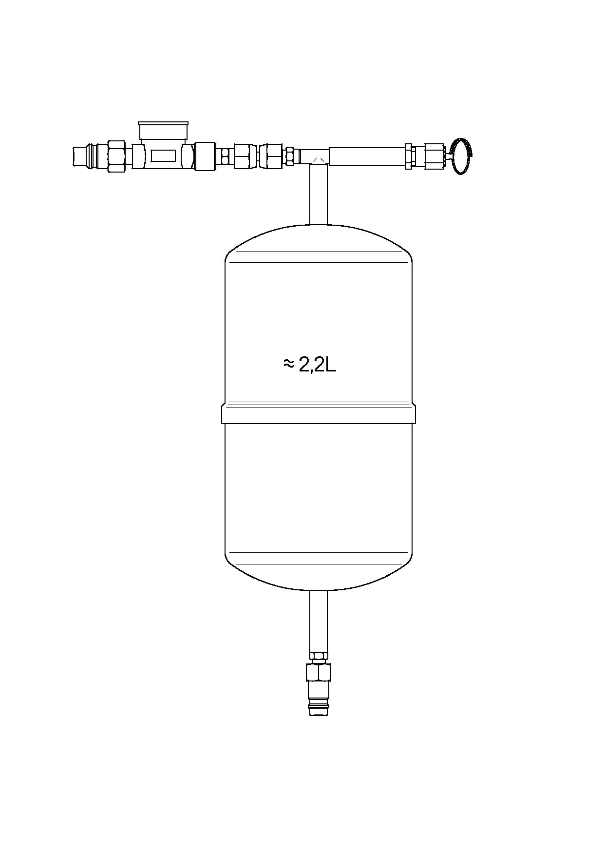
- Consecutively numbered list of the measured ACTUAL values and the resulting deviations per measurement

Figure 1: The figure shows an example of a test storage bottle with a high side and low side connection (and one connection for the creation of pressure to test the discharge of non-condensable gases) with a volume of 2.2 litre.
Note on security:

The valve of the test storage bottle must always point upwards during connection or disconnection of the high side service coupling. The test storage bottle must be fixed in this position with an adequate fixing device.

Attention: Refrigerant may escape when the service coupling is disconnected. The user must follow the general safety regulations for the handling of the refrigerant R-1234yf. The user must wear adequate protective clothing (goggles and protective gloves, etc.).

Note on the scale:
The measuring range of the scale must be > 5 kg and have a precision of ± 1 g.

Test preparation:
- Check the temperature of the test room according to the above mentioned specifications (4 temperature levels).
- Connect the low side and high side service couplings to the valves of the storage bottle and open them.
- During the refrigerant recharge process, the scale with the test storage bottle must always be placed at a height of 1.0 m above the floor (placement of the service unit).
- Hold the valve with the high side connection of the test bottle vertically upwards (if necessary, fix with an adequate fixing device).
- Empty completely the test bottle with the service unit.
- Keep a vacuum time of at least 10 minutes.
- Close the low side and high side service couplings.
- Set the scale to zero (empty test bottle is tare weight).

Test description:
- Select the filling quantity on the AC service unit according to the above mentioned criteria; check the value on the display.
- Do not add refrigerant oil or UV additive!
- Open the low side and the high side service couplings on the bottle valves.
- Start with the test filling (follow the individual steps in the service menu)
- -> follow the indications of the service unit.
- Close the valves on the service couplings on the low side and high side and evacuate the service hoses.
- Record the ACTUAL quantity (= filling quantity, display on the scale) in the evaluation template.
- Open the valves on the low side and high side service couplings.
- Evacuate the refrigerant from the test bottle.
- Record the displayed value of the recovered refrigerant quantity (precision of recovery).
- Read and record the weight of the test bottle on the scale (for the calculation of the remaining quantity refrigerant in the test bottle).
- Evacuate the test bottle (10 minutes) and repeat the process respectively.
- 3 measurements respectively at 15 ºC for 300 g/ 500 g and 900 g
- 3 measurements respectively at 25 ºC for 300 g/ 500 g and 900 g
- 3 measurements respectively at 35 ºC for 300 g/ 500 g and 900 g
- 3 measurements respectively at 45 ºC for 300 g/ 500 g and 900 g
- Determine the value of the deviations for filling quantity, recovered quantity and displayed quantity of the refrigerant.
- The test criteria may be exceeded only once in each of the following, Filling Deviation (g), Actual Recovered Quantity (%) and Displayed Recovery Deviation (g)for each test temperature

Maximum refrigerant oil discharge during evacuation
To keep the loss of refrigerant oil from the AC refrigeration circuit of the motor vehicle as low as possible during the evacuation process, the service unit must extract gaseous refrigerant exclusively from the vehicle for 2 minutes in the first step of the evacuation process (for example by reducing the evacuation speed)

Scale accuracy reliability.
- The unit should be moved along a 5 m long path, with a 2cm (+ or -0,1 cm) step. (See illustration)
- The path should be covered in 5 to 10 s, and the test repeated 5 times.
- If applicable the scale lock should be unlocked.
- Pass/fail criterion: charge accuracy the unit shall maintain its charge accuracy after the test – charge accuracy test to be repeated after moving the unit along)
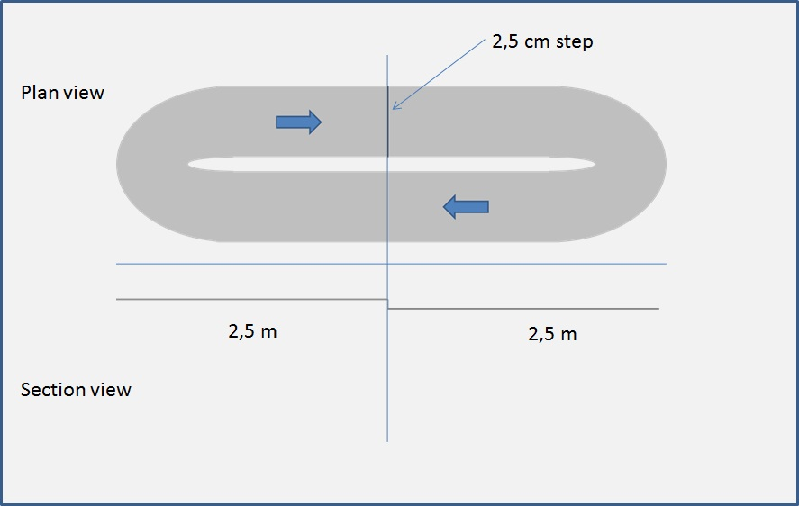

Figure 2 – Scale accuracy reliability test

General Service Documentation

Compliance Statement
The manufacturer must provide proof of the compliance of the product with all current European legislation or regulations applicable to this product.

These are, at the issue date of this document, currently:-

- the European Low Voltage Directive 2006/95/EC
- the European Directive for Electromagnetic Compatibility EMC 2004/108/EC
- the European Pressure Equipment Directive 97/23/EC.

Risk assessment
The manufacturer must provide a risk assessment and best practise guidance regarding the use of the refrigerant R-1234yf and associated equipment during its designed operational use.

Test results
The individual records or test results of the tests and controls described in chapter 9 must be certified by a notified and accredited testing facility. To this end, the manufacturer must provide the respective plausibility checks and documentary proof in form of calculations, material certifications and measurement protocols.

Accompanying Documentation
Operating instructions
MAC Servicing Best practise guide
CoC to applicable current European Standards
CoC to EGEA specification.

Operating instructions
Should contain as a minimum the legal requirements for clear and understandable instructions. In addition clear information concerning the use of R-1234yf and associated risks.

The manufacturer must insist and remind strongly that only and exclusively the refrigerant R-1234yf (2,3,3,3-Tetrafluoropropene / C3H2F4) must be used and the use of a refrigerant identifier is highly recommended.

Initial commissioning should be provided to personnel that have been trained and are qualified to work on MAC. At the point of initial commissioning the risk assessment and best practise concerning R1234yf should be highlighted.

Appendix 1

An electronic version of this worksheet is available from the EGEA Website WG9 download area.

Amendment Record

Version | Amendment | Chapter | Date | By Whom

