CEN/TC XXX
Date: 2017 09 17
prEN XXXXX: XXXX
Secretariat: XXX
Suspension tester specifications — SPECSUS2017
German — SPECSUS2017
French — SPECSUS2017

CCMC will prepare and attach the official title page.

Contents Page
No table of contents entries found.

European foreword
This document (prEN XXXX:XXXX) has been prepared by Technical Committee CEN/TC XXX “Title”, the secretariat of which is held by XXX.
This document is currently submitted to the CEN Enquiry.
This document will supersede EN XXXX:XXXX.
In comparison with the previous edition, the following technical modifications have been made:
This document has been prepared under a mandate given to CEN by the European Commission and the European Free Trade Association, and supports essential requirements of EU Directive(s).
For relationship with EU Directive(s), see informative Annex ZA, which is an integral part of this document.

[NOTE to the drafter: Add information about related documents or other parts in a series as necessary. A list of all parts in a series can be found on the CEN website.]

Introduction
General
These specifications are based on the EUSAMA recommendations and the SAE Technical Paper 960735, 1996, Tsymberov A., adapted for application in the Belgian Periodic Technical Inspection (PTI) after a study program carried out in 2010.
The EUSAMA suspension testers utilized by GOCA before these specifications are although designed to work within the frequency domain, up till however they have been limited to the magnitude response of the suspension system. This result, a EUSAMA value, usually referred to as “road” adhesion, is indicative of the safety of the vehicle; however, it is unreliable in determining the performance of the dampers. The present specification provides, along with the magnitude response (adhesion), the phase response of the wheel versus the movements of the excitation plate. The EUSAMA frequency function (established by a flywheel) is made variable by a frequency inverter in order to increase testing time in the neighbourhood of the unsprung mass frequencies, thus enabling a more correct measurement by exciting more energy.
The suspension tester must comply with the specifications at the time of approval (par. 6), of purchase as well as at the time of putting into service which includes the first inspection by the supervisory body recognized by the FOD, as has been the case for each and every suspension tester which has already been approved by version TCDI051D dated 25.09.90 and addendum dated 14.06.91.
Given that these specifications describe new approval criteria small modifications to the procedure and the software are possible when this inspection starts. The suppliers are to guarantee definite flexibility for possible software and hardware adaptations for at least up to 2 years after the publication date of these specifications or up to 1 year after the imposing, by Royal Decree, of inspection of the suspension test combined EUSAMA / minimum phase shift.
The information which is to be supplied by this equipment gives indications concerning the condition, the damping capacity and the “road” adhesion capacity of the suspension system of a vehicle. These indications do not necessarily correlate to suspension tests results obtained in road trials.

General use for vehicle inspection
Measurement method and testing devices need to be suitable for vehicles of the categories M1 and N1. Testing devices have to be capable to measure axle loads of up to 1700kg. The test procedure has to be performed within an appropriate time.

Method of measurement
The evaluation is based on introducing forces/energy into the suspension system and look for characteristics of the whole suspension and the damping. The efficiency is evaluated per wheel in order to arrive at the evaluation of the suspension system in total (as this is a check without dismantling, malfunctioning cannot be related to individual parts).

Identification of patent holders, if any.

Scope
Text of the scope.

Normative references
The following documents are referred to in the text in such a way that some or all of their content constitutes requirements of this document. For dated references, only the edition cited applies. For undated references, the latest edition of the referenced document (including any amendments) applies.
EN XXXX-1:XXXX, General title of series — Part X: Title of part
EN XXXXX (all parts), General title of the series
[NOTE to the drafter: The Normative references clause is compulsory. If there are no normative references, add the following text below the clause title: "There are no normative references in this document."]

EUSAMA SPECIFICATION
Everything that is in original specification and is used here only reference or rewrite here?
TSYMBEROV
PASCAL – CITA + IMPLEMENTED
PHASE SHIFT x DAMPING RATIO?

Terms and definitions
- For the purposes of this document, the following terms and definitions apply.
- ISO and IEC maintain terminological databases for use in standardization at the following addresses:
- IEC Electropedia: available at http://www.electropedia.org/
- ISO Online browsing platform: available at http://www.iso.org/obp

Static weight sw or static force Fst
is the weight of the wheel on the suspension tester platform before the test (sw = Fst = F = Fr)

Vertical tire contact force signal F(t)
is during the test force acting between the tire and the suspension tester platform. It is shortened as tire force signal F(t).
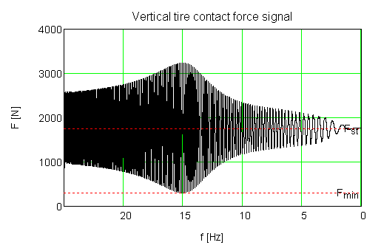
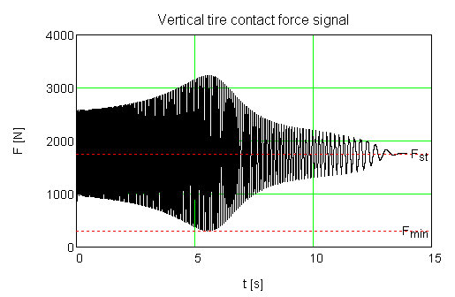

Dynamic force signal of the suspension tester platform Fp(t)
is during the test force generated by the empty suspension tester platform during its vertical oscillations. It is shortened as platform force Fp(t).
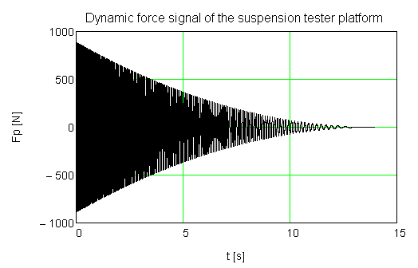

Raw force signal Fr(t)
Is during the test force measured directly by transducers placed below the suspension tester platform.
Before the test: F = Fr, Fp = 0, during the test: F(t) = Fr(t) - Fp(t)
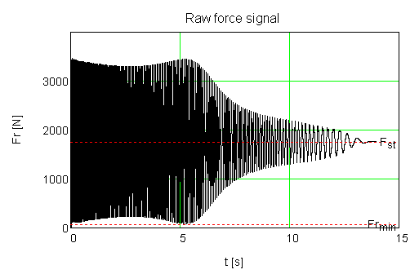

Top position of the i^{th} period of the vertical tire contact force signal T(i)
is the middle of the up and down intersections of the vertical tire contact force signal F(t) and the static weight of the wheel Fst.

Top position of the i^{th} period of the suspension tester platform Tp(i)
is the middle of the up and down intersections of the dynamic force of the suspension tester platform signal Fp(t) and 0,
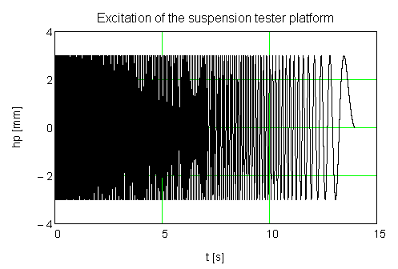
where $Fp\left(t\right)= m_{P}* \ddot{h_{P}}(t)$ and h_{P}(t) is excitation of the suspension tester platform

Maximum of the i^{th} period of the F(t) signal maxF(i)
The sequence of maxF(i) create upper envelope of the F(t) signal.

Minimum of the i^{th} period of the F(t) signal minF(i)
The sequence of minF(i) create lower envelope of the F(t) signal.

Peak to peak amplitude of the i^{th} period of the F(t) signal ΔF(i)
is expressed by the form ΔF(i) = maxF(i) - minF(i)

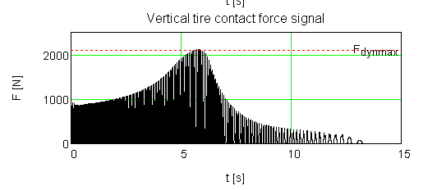
Maximum amplitude of the F(t) signal Fdynmax
$$Fdynmax=\max\left(F\left(t\right)\right)-Fst$$
The Fdynmax could reach the limit of the physical registration of the contact force signal (overflow, top of sinewaves is cut off).

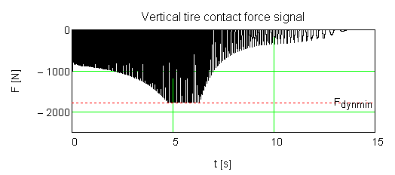
Minimum amplitude of the F(t) signal Fdynmin

$$Fdynmin=\min\left(F\left(t\right)\right)-Fst$$
When Fdynmin <= -Fst (underflow, bottom of sinewaves is cut off) and Fdynmax should be used in further calculations.

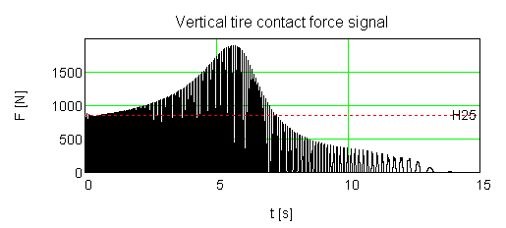
Static amplitude H25 of the F(t) signal

is the average amplitude (ΔF(i)/2) of approximately first 10 periods of the F(t) signal, while the motor runs on 25 Hz.

Rigidity of the tire
Is measured by a frequency between the resonance frequencies of the suspension and these of the tire; this means by 25Hz (check units m/mm/kg/N)
$${rig}_{raw}= \frac{0.612}{3}*H25$$
$$rig= k_{rig}*{rig}_{raw}+ q_{rig}$$

Adhesion
in the context of this suspension test, is the minimum percentage of remnant vertical tire contact force F(t) between the tire and the vibrating suspension tester platform during vertical oscillation of the wheel. This percentage is obtained by calculating the ratio of the minimum remnant vertical load to the static weight (vertical tire contact force) on the suspension tester.

Minimum adhesion
is the lowest value of adhesion throughout the test
$$MinAdh :=100*\frac{Fmin}{Fst}$$

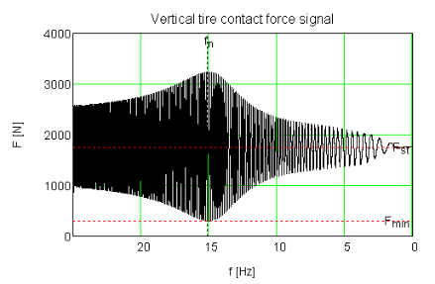
Minimum adhesion frequency fn

When Fmin > 0, the minimum adhesion frequency fn is determined the natural way.

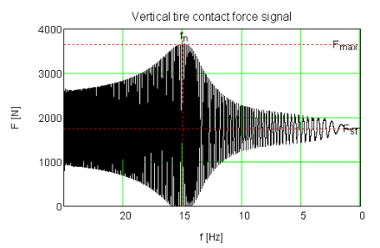
When Fmin <= 0 (underflow, bottom of sinewaves is cut off) and Fmax exists, the minimum adhesion frequency fn is determined as the frequency of the maximum of the tire force signal F(t).

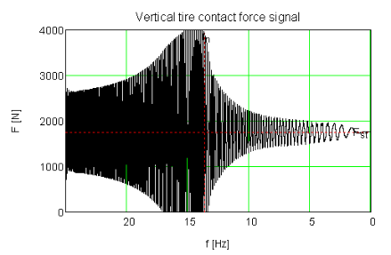
When Fmin <= 0 and Fmax at the same time goes above the limit of the physical registration of the contact force signal (overflow, top of sinewaves is cut off), the minimum adhesion frequency fn is determined from the first waveform where tire force signal gets back within systems hardware range.

Phase shift φ
is the angular difference between the absolute “sinusoidal” position of the suspension tester platform and the “sinusoidal” vertical tire contact force between the tire and the suspension tester platform.
In the practice the phase shift φ(i) is for each period of the suspension tester platform signal Fp(i) calculated from the top position T(i) of the vertical tire contact force signal F(t) and the top position Tp(i) of the dynamic force signal Fp(t).
The top position Tp(i) of the suspension tester platform is measured in the indirect way.
Because the static weight of the wheel Fst is not always about the middle of maxF(i) and minF(i), the top position T(i) of tire force signal is for each period i determined by the following way, introducing parameters RSWfMAX = 25% and RSWfMIN= 25%.
$${sw}_{lo}=minF\left(i\right)+ΔF\left(i\right)\frac{RSWfMIN}{100}<F_{up}\left(i\right)<maxF\left(i\right)-ΔF\left(i\right)\frac{RSWfMAX}{100}={sw}_{hi}$$
$${sw}_{lo}=minF\left(i\right)+ΔF\left(i\right)\frac{RSWfMIN}{100}<F_{dn}\left(i\right)<maxF\left(i\right)-ΔF\left(i\right)\frac{RSWfMAX}{100}={sw}_{hi}$$
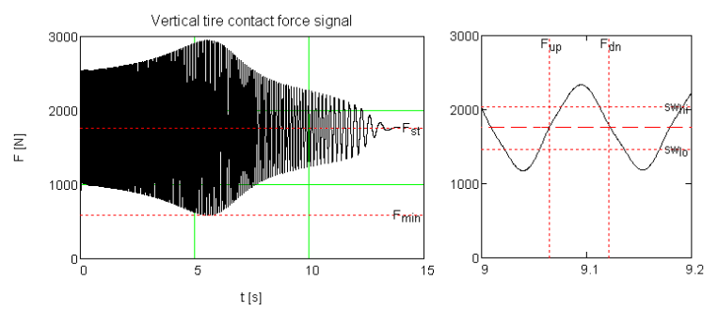
Intersections Fup and Fdn are available and fulfill the above conditions. Phase shift can be calculated.

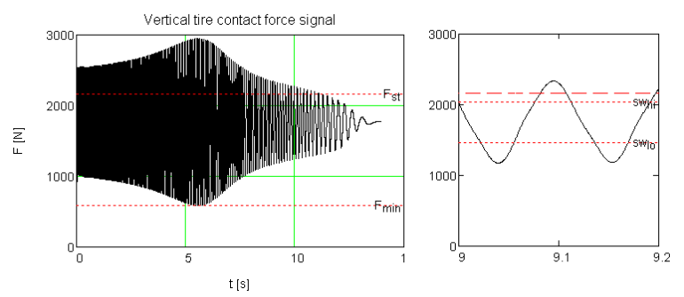
Intersections of the tire force signal F(t) and the static weight Fst exist but don’t fulfill the above conditions. Phase shift can’t be calculated.

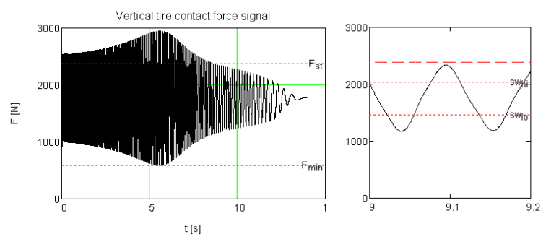
Intersections of the tire force signal F(t) and the static weight Fst don’t exist at all. Phase shift can’t be calculated.

For phase shift calculation (in the range of 18Hz to 6Hz) the force signal F_{T}(t) must be digitally filtered with such a filter, that doesn't change the force signal phase but removes all parasitic influences.
Phase shift signal processing & phase shift source signal processing – where.

Minimum phase shift φ_{min}
is the lowest value of the phase shift φ determined during the test. Minimum phase shift should be detected in a frequency range that is maximum DeltaF (parameter: DeltaF = 5Hz) below the minimum adhesion frequency fn.
Uniquely specify frequency range for Phase Shift.
Note 1 to entry:
[SOURCE: EN XXX:XXXX, definition XX]

Theoretical principle

EUSAMA Method

Origin
In the August/September 1976 venue of the ImechE Journal, the following paper: “Suspension Performance Testing” could be read. The authors are working for the EUropean Shock Absorber Manufacturer Association (EUSAMA). This organisation doesn’t exist anymore.

Test principle
At the resonant frequency of the unsprung mass the displacement between the unsprung mass and the suspension tester platform is at maximum, or adhesion is at minimum. Unsprung mass resonance can be seen graphically as the minimum inflection point on the adhesion verse's frequency graph. The EUSAMA value is calculated as mentioned in formula [1]. If the wheel stops making contact with the platform during a test, the minimum adhesion is zero. Low percentages describe low performing suspension, high values good performing suspension.
EUSAMA VALUE (%)= (Ni,j dyn min)/(Ni,j Static) * 100 (%) [1]

Minimum phase angle method Subclause title

Origin
In the SAE Technical Paper 960735, 1996: “An improved Non-Intrusive Automotive Suspension Testing Apparatus with Means to Determine the Condition of Dampers” could be read. The author was Tsymberov A.

Test principle
The minimum phase angle value is indicative of the strength of the damping. The minimum phase angle is the lowest value of the phase angle determined during the test between the sprung and unsprung mass resonant frequencies. When adequate damping is present in the suspension system there will be a smoother response delay of the wheel to the moving platform at the unsprung mass resonant frequency.

Description of the system

Principal components of the system
The suspension tester is an equipment capable to test individually either one of the wheels of one axle of a vehicle as described in this document by means of vibrating platforms, and all necessary hardware to comply with the specifications herein:

- Example given: AC Motor, shaft(s), flywheel and chain / belt / … drive

- Platforms designed for vibrating vertically (To add a tolerance) in the range of 25 Hz -– 5 Hz with a peak to peak amplitude h_{PS} = 6 mm (tolerance ±0.3 mm), h_{PSmeasured} is the statically measured peak to peak amplitude. Peak to peak amplitude shall be measured at any point between 0.25 a 0.75 through the length of the transversal axis of the plate.

- Maximum of peak to peak amplitude difference between left and right platforms shall be limited to |h_{PSmeasured,Left} – h_{PSmeasured,Right}|<=0.2 mm ). Peak to peak amplitude shall be measured in the center of the plate. Peak to peak amplitude shall be measured at any point between 0.25 a 0.75 through the length of the transversal axis of the plate.

- Platforms designed with dynamically measured peak to peak amplitude h_{PD} = h_{PSmeasured} ± 0.3 mm. (tested against rear axle about 600 kg, native Eusama ~20), |h_{PDmeasured,Left} – h_{PDmeasured,Righ}t|<=0.3 mm ). Peak to peak amplitude shall be measured beside the wheel positioned on the center of the plate, in the frequency range 18-6Hz.

- The top face of the plate has to be flat or with V shape with an angle of less than 1.5 degrees.
Each platform shall be equipped with one or more weighting device(s) able to measure raw force signal.

- Weight measuring points must be able to measure also negative force (dynamically without the car on the plate).
- Means/Sensor(s) to detect the platform’s vertical position.
- The vertical position of the oscillating platform is to be determined by at least one point per cycle.
- Means/Frequency variator, in order to have frequency variation like described in the next chapter
- Analog output of weight measuring devices shall have such an amplitude/frequency characteristic that further supports all digital signal processing.
- Control system with the A/D converter.
Sampling frequency f_{s} of the F(t) signal should exceed 1500 Hz, detection of the plate’s top position Tp(i) should be with the error less than 300 µs.
Sampling frequency fs of the F(t) signal and detection of the plate’s top position Tp(i) have to be adequate to fulfil demands of point 6.1.5 of this document.
Amplitude characteristics of the ADC inputs has to remove parasitic influences introduced by the used frequency inverter.
- Signal processing for the plate position and weight signal may introduce a phase delay between each other, such delay shall not exceed 3 degrees.
- Software capable to perform further digital filtration of input signals. Description of filters, adhesion calculation, phase calculation, means for the correct phase calculation, appendix 1 or ‘detailed’ description of phase signal processing here.

A system for the centralization, processing and display of measurement results. This system will be discussed in detail in parts 4.3 and 4.4;

The required calibration equipment. The calibration equipment is to comply with the requirements which are imposed by the standard ISO 17025.

Digital signal processing

General
Terminology and filter used by the GOCA implementation are based on the article J.F. Kaiser and W.A. Reed, ‘Data smoothing using low-pass filters’, Review of Scientific Instruments, Volume 48, Issue 11, pp. 1447-1457 (1977), Method 1 – Nearly equal ripple approximation filter.
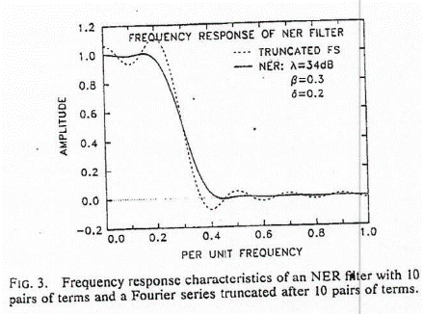
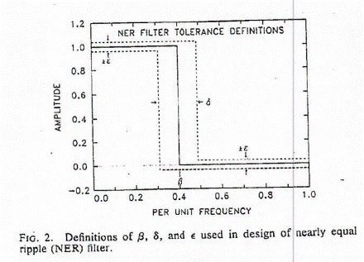

F(t), Fp(t), minimum adhesion
Whole signal, ε = 0.01, pass band 0-50 Hz, stop band 130 Hz –>

Phase shift processing
There are more influences (nonlinearities, impacts, …) that on the real vehicle during the test corrupt phase signal against the one known from the theory based on the ¼ car model.
Proposed phase signal processing corrects most of such influences (see Annex B).

Filter for the F(t) signal – raw phase shift φ_{r}(i) calculation
For each frequency step f_{step} of 1 Hz in the frequency range 20 – 5 Hz create unique filter according 5.2.1 using following parameters fPassMul = 2, fStopMul = 4
f_{step} = 20, 19, … 5 (this is not a real parameter, it is software constant)
ε = 0.01
for each f_{step}, pass band = 0 – f_{step}* fPassMul Hz
for each f_{step}, stop band = f_{step}* fStopMul Hz ->

Raw phase shift φ_{r}(i) processing
Parameters MinPhLim = -20, MaxPhaseLim=180, WLIncr = True, TLtoWL=2 (samples, @1800 Hz).
From the raw phase shift φ_{r}(i) signal remove all elements, that don’t fulfill above parameters, create processed phase shift φ_{p}(i) signal.

Result phase shift φ(j,ω) signal
Resample/resize φ_{p}(i) signal to equidistant in the frequency range.
Apply Gaussian filter (parameter GsFltOrd = 20).
Using variance of Δφ(j) replace incorrect elements by better approximations.

The characteristics of the system must allow the following elements to be determined at least
The subscripts used in further values define the axle and wheel (side) of the tested vehicle: i stands for the tested axle (1,2,... with 1 as the front axle) and the j for the vehicle side (l = left and r = right).

The vertical force F_{i,j}, defined as the vertical force of a wheel, exercised on the platform.
This force must be able to be measured statically (Fst_{i,j} static) as well as dynamically (F(t)_{i,j} ).
Fmin_{i,j} is the minimum dynamic registered vertical force.
Fmax_{i,j} is the maximum dynamic registered vertical force.

The vertical force AF_{i} of an axle, defined as the sum of the vertical forces, of the wheels of one and the same axle of the vehicle.

The minimum adhesion value MinAdh_{i,j}, defined as the minimum percentage of remnant vertical tire contact force between the tire and the platform during vertical oscillation of the wheel (defined in 3.13).

The unbalance of the minimum dynamic force values DFdynmin_{i} for each axle, defined in the following way (see definitions of Fdynmin in 3.11):

$${DFdynmin}_{i}= \frac{\left|\left|{Fdynmin}_{i,1}\right|-\left|{Fdynmin}_{i,2}\right|\right|}{max⁡(\left|{Fdynmin}_{i,1}\right|,\left|{Fdynmin}_{i,2}\right|)}*100$$

The minimum phase shift φmin_{i,j}, defined as the minimum phase shift of a wheel.

The unbalance of the minimum phase shifts Dφmin_{i} for each axle, defined as the ratio of the difference in absolute value of the left and the right minimum phase shift to the greatest minimum phase shift of the left of the right wheel of this axle.

The Adhesion and Phase shift-graphs are the graphs of the phase shift φ and the adhesion functions in the frequency range from 25 Hz down to 5 Hz.

The suspension tester shall indicate if the rigidity rig_{i,j} of the tire (measured by a frequency between the resonance frequencies of the suspension and these of the tire; this means by 25Hz) is sufficient and this with the purpose of having an idea of the tire pressure.

The frequency variation function from 25 Hz down to 5 Hz
The platform has been excited by a frequency variation function rom Figure 1, and amplitude (about +/- 3 mm, paragraph 5.1) sine function.

The power supply and the frequency variator drive system shall should be capable of driving the platform, when loaded to its maximum from rest position to its maximum frequency of about 25Hz (+-1Hz) in considerably less than 2,5 seconds. An overrun at 25Hz is allowed but should be minimized. In order to measure the rigidity (paragraph 3.13) of the tire by 25Hz the suspension tester will be at this frequency for 0,5 seconds after the stability of the vehicle is obtained minimum 2,5 s. A linear cost down should be obtained from 25Hz to 18Hz in order to minimize the test duration. Further going down from 18Hz to 6Hz with a semi-linear pass-through of 7.5 s from 18Hz to 6Hz and continued until 6 Hz. Below 5Hz the converter may brake the flywheel or don’t care.

Measurement of the second wheel of the axle can start when there is no vertical movement of the first wheel plate.

Minimum duration before measurement starts on 25 Hz:

ΔT₂₅ (ms)= F_{st} (N)*0.16 + 1200

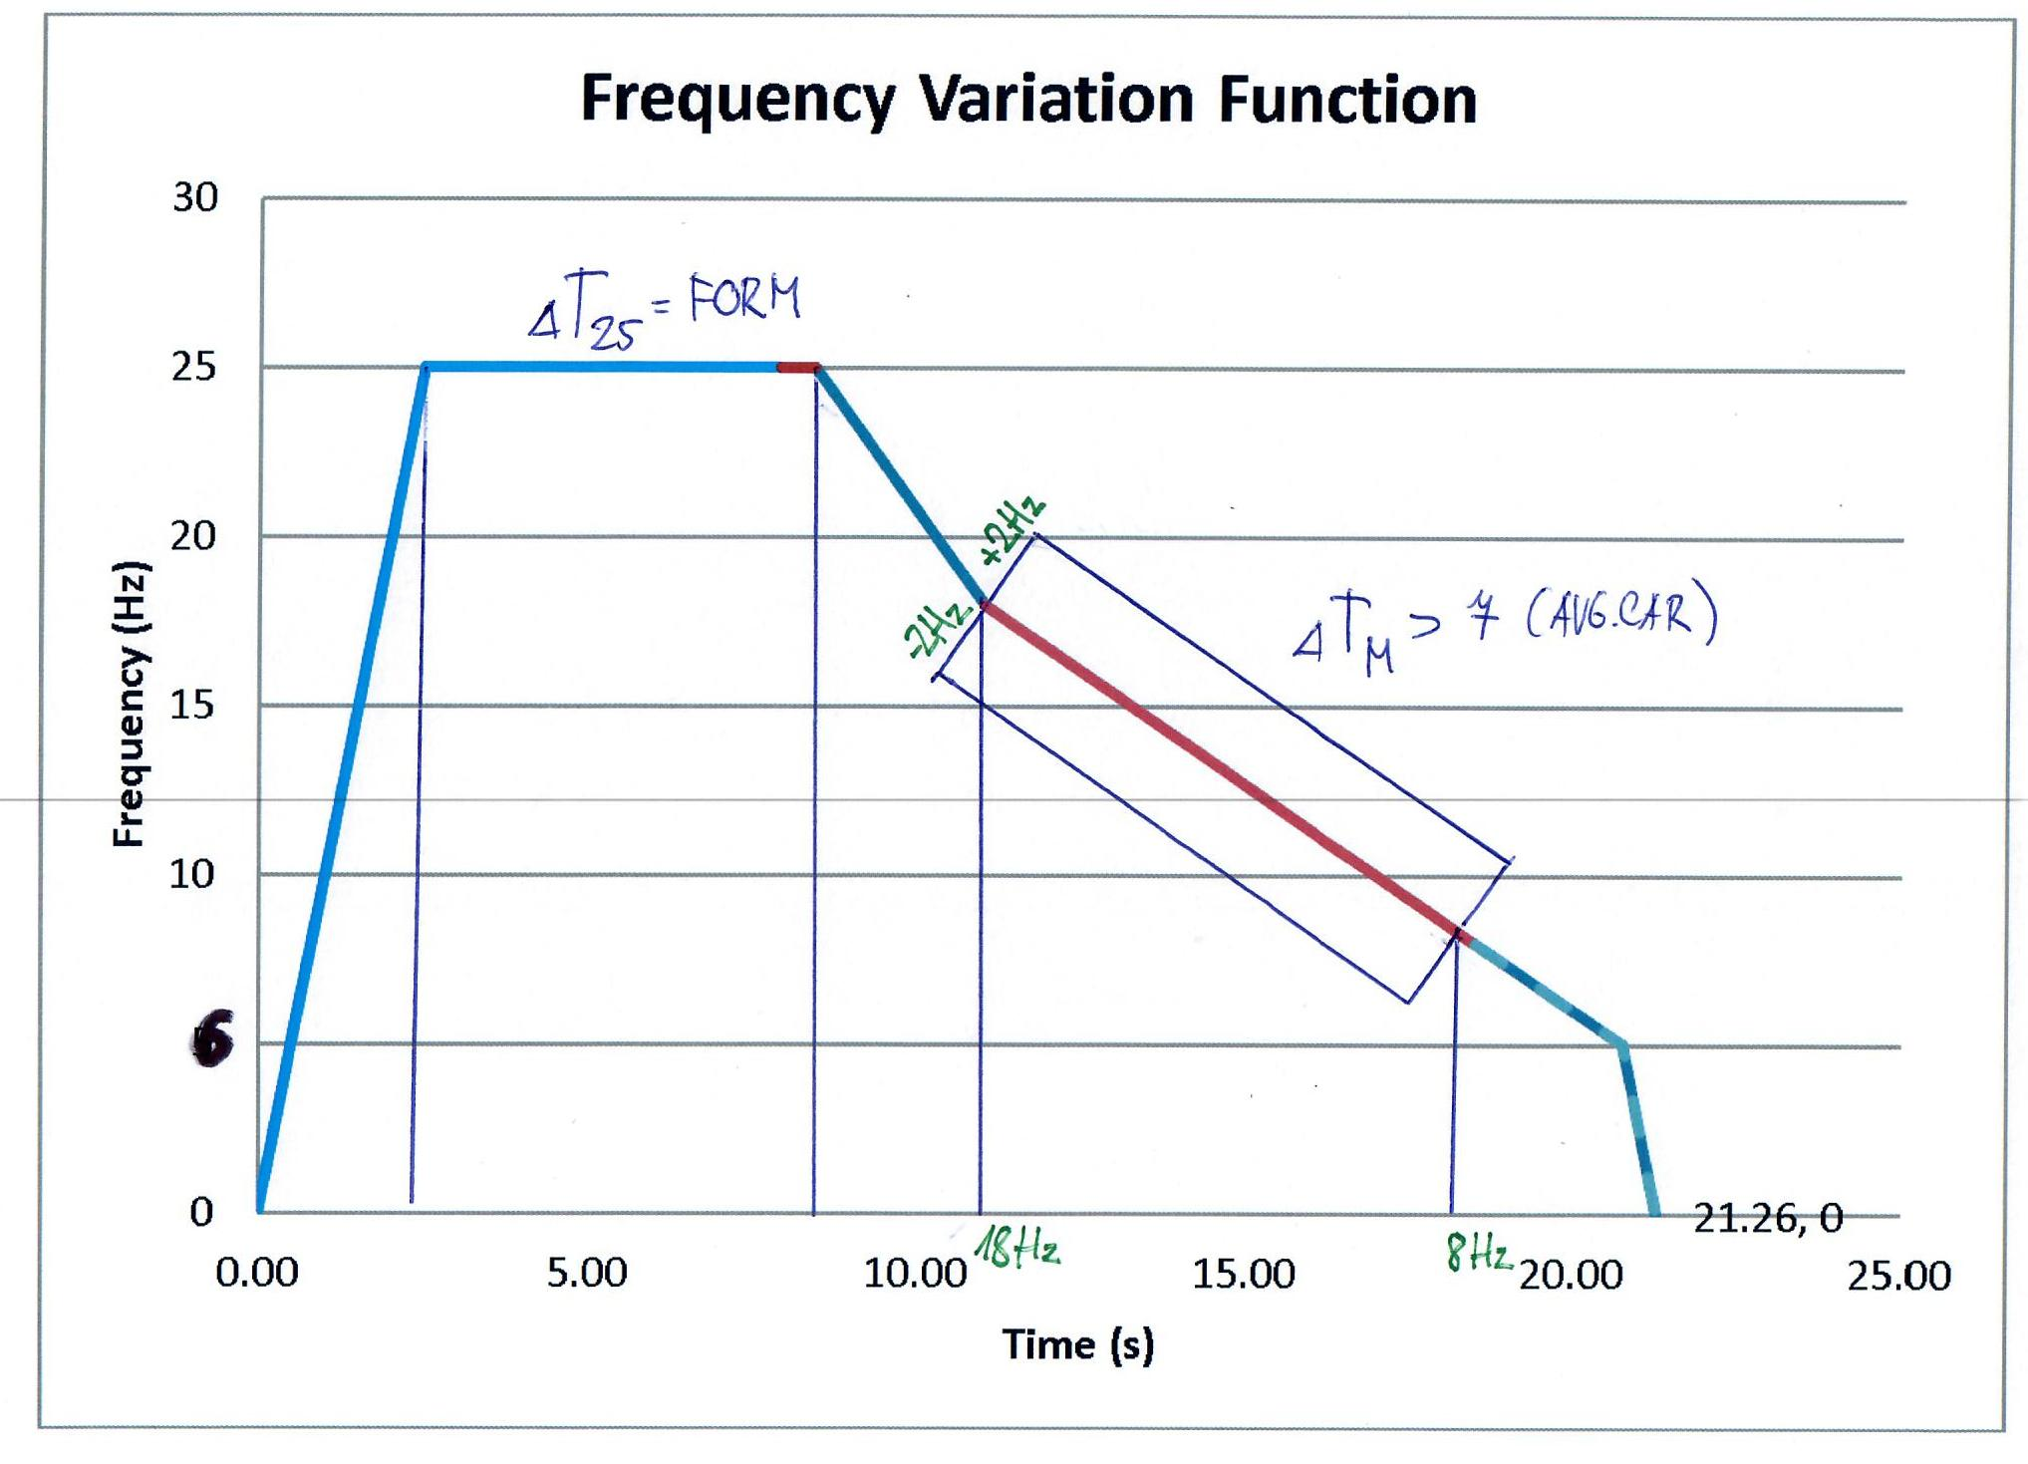
Figure 1: Frequency Variation Function PASS / FAIL criteria
In principle, different types of pass/fail criteria can be established. They will be explained here as absolute or relative criteria.

Absolute criteria
The European Shock Absorber Manufacturers Association (EUSAMA) established the following guidelines for adhesion:

Adhesion Measured | EUSAMA Interpretation
61% to 100% | Excellent dynamic wheel contact
41% to 60% | Good dynamic wheel contact
21% to 40% | Fair dynamic wheel contact
1% to 20% | Poor dynamic wheel contact
0% | Bad dynamic wheel contact

Therefore, the absolute criterion for EUSAMA is set up to 20% (parameter ACEUS = 20% E).

Add table of Minimum phase shift values

A. Tsymberov wrote in his SAE paper that dampers with minimum phase angle less than 40 degrees, corresponding to damping ratio 0.08 of the unsprung mass, are considered to be weak.
Therefore the absolute criterion for Minimum phase shift φ _{min i,l} is set up to 40° (parameter AC_{φmin}= 40°)

Relative criteria
Relative criteria are based on comparing the set of results between the left and right wheel for each axle of a vehicle, e g unbalance of the results for one axle. Without any doubt, it is clear that the same level of suspension is intended for the wheels of an axle of a vehicle. Higher differences will identify a defect of the system.

Only recommended values used by GOCA, also for minimum ph.

The relative criteria for dynamic force Dynamic force value and Minimum phase shift φmin i,l is set up to 30%, (parameters RCDYNF = 30% and RC_{φmin}= 30%).

The unbalance for EUSAMA value is set up to 50% for so far that the Eusama values of both axles are more than the absolute criterion for EUSAMA AC_{EUS} = 20%:
- General relative criterion Dynamic force inbalance left/right <= 30% of the highest value, see Appendix 2

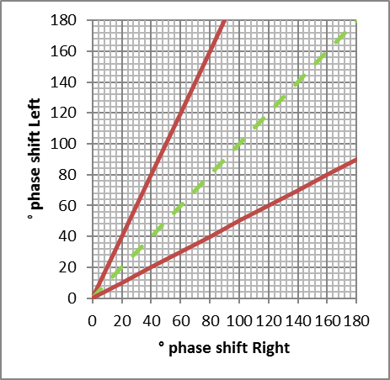
Fig 3 : Relative Criteria Phase shift

Requirements for inspection devices

Technical requirements for testing devices

General
Any suspension testing device should be capable to evaluate values for suspension characteristics per wheel for vehicles N1 and M1. The operation of a suspension testing device should not extend the time for PTI (Periodic Technical Inspection) significantly. Testing devices have to be built on good engineering standards, covering all applying requirements for technical devices in general (e g directives to product safety, …).
The construction and functioning of test devices should be designed in a way that will not cause any damages to tested vehicles but which is easy to operate with low maintenance costs and may be prepared for automatic data transfer.

- The suspension tester should be capable of testing, without any adjustment vehicles with:
• Static wheel loads of from 100 up to at least 850 kg
• Tracks from 1000 (Internal) up to at least 1700 mm (external)
• Wheelbases varying from left to right by up to 100 mm on the same vehicle;
- The installation must, without suffering any damage or adverse effects on its metrological or other qualities, and for over at least 5 years, be able to tolerate the loading, the impacts and the vibrations which are exercised or caused by the wheels on the platform during normal operation of the bench in the abovementioned loading conditions. By normal operation is meant a usage of a minimum of 300 measurements (a= axles) per day.
- The normal operation of the equipment has to be guaranteed for an environmental temperature of between -5 °C and 35 °C.
- A simple selection should allow the suspension tester to be put in the automatic (normal) cycle. The operation for this selection must be easily accessible.
- Sufficient measures need to be taken in order to ensure that no negative effects can come about due to condensation of damp
- The suspension tester also has to be protected against normal atmospheric circumstances, against corrosion and against the penetration of foreign (abrasive) materials in the bearings or moving parts; It also has to be protected against floor cleaning products and dirt and (salt) water falling from the vehicles during tests.
- The measures which the manufacturer has taken in order to comply with points 4.3 and 4.4 of this paragraph are to be described in the Technical Dossier
- The means of measurement or the means of measurement of the vertical loading must be provided with an adjustment device which is moreover secured against arbitrary manipulation. The calibration and adjustment must be able to take place within an acceptable time frame (less than 120 minutes) and it must be easy to dismantle these when required.
- The suspension tester must start up automatically, after positioning of the vehicle and when a considerable stable static vertical force is measured.
- The means of measurement must carry the CE mark. All obligations are to be complied with within the context of CE marking and the machine guidelines are wholly the responsibility of the supplier of the suspension tester.
- All parameters (see point 5 (parameter)) which are governed by software have to be secured, and it must be possible for an authorized user to adjust and secure these easily. All parameters have to be retained and it must be possible at all times to print out the valid settings on a dated print-out.
- The equipment must, for initial scale maintenance, be easily accessible and one should be able to clean them easily, so that this maintenance can be carried out within a reasonable time scale.
- The equipment must be provided with an emergency stop function. The emergency stop function must be located in the vicinity of the suspension tester, PC or console.
- The means of measurement has to comply with all the conditions as laid down in the Flemish, Wallonian, Brussels, Belgian and European laws, regulations, guidelines and standards valid at the time of purchase with regard to safety, hygiene, working conditions (amongst other. Belgian Law on Welfare 04/08/1996, ARAB, CODEX, AREI, ...) and the environment, in particular, amongst others:
  - machines (guideline EEG 2006/42 and adaptations – K.B. 12.08.2008),
  - low voltage (guideline 2006/95 and adaptations – K.B. 10.1.97),
  - EMC, ElectroMagnetic Compatibility (guideline 2004/108 and adaptations – K.B. 28.2.07),
  - Personal protective gear (guideline 89/686 and adaptations – K.B. 31.12.92 and modifications),
  - Working methods (guideline EEG 89/655 and adaptations – K.B. 12.08.1993, included in CODEX).
- The electrical signals of the vertical forces and the vertical position of the oscillating platform measurements must be filtered so as to allow a correct evaluation of these direct measurements, as well as of the derived quantities relating to damping capacity and unbalance. The response times of the different quantities measured should be very small. The filtering processes and the response times for the different direct measurements should always remain coherent, so that these measurement results themselves as well as the derived quantities are always based on measurements which have taken place at the same time or measurements taken within the same time interval. The definitions and characteristics of these filters should be notified to GOCA. These filters should preferably be adjustable by setting the parameters via the software.
- The devices will protect against false operations and against excessive variations of voltage supply. The unit will be provided with a three-phase power supply 220/380V AC 50Hz. Fluctuation of the power supply by + / -15% will not affect the accuracy of the measurements or disrupt the automatic operation.

Operation and characteristics of the suspension tester

- The devices will allow the measurement by successive independent sequences of left and right suspension from the same axle without having to manoeuvre the vehicle.
- The tests will require no action on the vehicle.
- The tester starts only after both the wheels are well placed on the platform and after a time delay of 1 to 3 seconds
- The platform should be generally flat and should be subjected to a substantially sinusoidal vertical oscillation of 6 mm (+/- 0,2 mm) total amplitude over all of its supporting surface; tested against VW Caddy, rear axle, Eusama ~20
- The suspension tester should be conceived so that one operator in the driving seat can perform the whole test of the four suspensions, including the displacements and the total average time for testing the four suspensions should not exceed 2,5 minutes;
- It must be possible to start and stop the suspension tester both automatically and manually. A system has to be provided to limit the motor starting current.

The installation must be possible to provide with a control whereby the platform can be activated manually in order to retest an axle.
Starting the motor will be secondary to the response of a safety device that is sensitive to the positioning of the stationary vehicle.
The starting of suspension tester is only possible if on each of both platforms the wheel of an axle is placed.. When a displacement of the tested wheel is detected during the test, the test should be reperformed.
Detected -> Limits
(Each supplier is to present his method used in order to determine displacement in detail for approval and for the attention of the R&D department of GOCA). It is only in the case of a test program that the motors can be started manually.

Measurement device for vertical forces

Type of measurement of vertical forces
The static weight Fst vertical force is measured only after the value is stable.

The static weight Fst shall be stored only when the measured value is stable.

Limit for weight fluctuation
The measurement of the vertical force must only be minimally influenced by the horizontal forces. In the technical dossier the manufacturer is to define his value for “stable”. The the R&D department of GOCA will accept or reject the defined tolerance.
The static vertical force will be measured at total standstill of the vehicle on the tire support platform before and after the test. The difference should not exceed 25 kg (parameter).

Measurement range and maximum permissible errors of measurement of vertical forces
The lower limit of the measurement range must be smaller than or equal to 100 daN static weight per wheel. The upper limit of the measurement range must not be less than 850 daN static weight per wheel. The resolution should be at least 1daN.
The measurement device must be able to take up at least a dynamic load of 1700 daN per wheel without damage, in order to make it possible for the vehicle to drive on and off at normal speed.
Within the measurement area the maximum allowable total error for the statical vertical force (inaccuracy, linearity and reading error included) is defined as follows:

Maybe here we don’t have to prescribe so sharp tolerancies, but on the other side if the weight measurement is poor then forces for phase shift measurement are wrong and desired preciseness can’t be reached
- From 0 daN up to 250 daN vertical force : ± 7,5 daN including hysteresis
- From 250 daN up to 850 daN vertical force : ± 3 % of the measured value including hysteresis
- From 100 daN up to 850 daN vertical force : +/-3 % for hysteresis

Zero point
The system for measurement of the vertical forces must be provided with a device which allows the zero point to be quickly adjusted or auto adjusted. This device must be such that any unwanted handling of this can be avoided.
The zero setting and the setting of the sensitivity of the vertical forces must be independent of one another, in other words after the zero point is modified the calibration of the vertical forces must not be lost.
If no force is applied to the tire support platform it should be possible to show the zero reading.

Measurements to be carried out
When a suspension test is carried out on a vehicle evaluation of the following must be possible:
- Ni,l static for each wheel
- EUSi,l, EUSAMA value for each wheel
- φmin, Minimum phase shift for each wheel
- EUSAMA and Minimum phase shift-graph for each wheel
- DEUS,i, value of the EUSAMA value unbalance for each axle
- Dφmin,i, value of the Minimum phase shift unbalance for each axle
- Rigidity of the tire for each wheel

Reproducibility, reliability
The evaluation of the suspension characteristics has to be based on a robust test procedure with low or controlled influence of environmental factors (temperature, load, tire, tire air pressure, ….). Where influences need to be controlled, this should be explained clearly in the manuals for these testing devices. Reproducibility and accuracy need to be on an appropriate level to ensure reliable results.

- The test reading must be repeatable under identical conditions with a permitted maximum tolerance of +/- 2% Eusama percent;
- The test reading must not vary by more than +/-3% Eusama percent for different positions of the tire on the test platform;
- The test reading must have a maximum permitted tolerance from the real percentage remnant dynamic vertical tire force of +/- 3,5% Eusama percent;
- The test reading must be repeatable under identical conditions with a permitted maximum tolerance of +/- 3° (GOCA 2°) of the minimum phase shift;
- The test reading must not vary by more than +/- 4.5° (GOCA 3°) of minimum phase shift for different positions of the tire on the test platform;
- The test reading must have a maximum permitted error tolerance from the phase shift of +/- 7.5° (GOCA 6°) phase shift to the reference tool
- The maximum permitted minimum phase shift error is 7.5° (GOCA 6°)

Calibration
Periodical traceable calibration of test devices has to be ensured. The calibration interval is intended to be 12 months, but not longer than 24 months. The drift of the system for the various direct measurements must be minimal. Therefore the direct measurements must fulfill the following at the periodic calibration:
- the peak to peak amplitude is 6 mm (+/- 0,3 mm) total
- Vertical force error according to 6.1.3.3
- The test reading must have a maximum permitted tolerance from the real percentage remnant dynamic vertical tire force of +/- 3,5% Eusama percent;
- Dynamic calibration according to point 3.3 and dynamic verification using special test mode that allows to start a test without a vehicle on the platforms.
- The test reading must have a maximum permitted tolerance from the phase shift of +/- 6° phase shift;
- Test of reproducibility according to point 6.1.5

It will be possible to change the key values and / or adjust them with a resolution of 1% of the measuring scale for EUSAMA-percentage.
The signal of the force over time must be registrable during one of the verification checks on the proper functioning of the device.
For the periodic inspection and the type approval procedures calibration devices / method could have the systematic error, which could be evaluated and corrected in backwards.

Device for the centralisation and display of measurement results
The values which are reproduced by the printer or on the screen must have the appropriate units.
The supplier is to make a proposal for the reproduction of the results on paper and on screen for approval by GOCA, for the attention of the technical commission. The measurement results have to be retained. The protocol of the data is described in point 4.3.2.

The following parameters must be displayed
Before starting the test (test of one wheel):
- Ni,r or Ni,l , measured before the start of the test.

During or at the end of the test of one wheel:
- Ni,l static for each wheel
- EUSi,l, EUSAMA value for each wheel
- φmin, Minimum phase shift for each wheel
- Rigidity of the tire for each wheel

At the end of the test (test of one axle):
- Ni,l static for each wheel
- EUSi,l, EUSAMA value for each wheel
- φmin, Minimum phase shift for each wheel
- DEUS,i, value of the EUSAMA unbalance
- Dφmin,i, value of the Minimum phase shift unbalance
- Rigidity of the tire for each wheel

During or at the end of the test:
- EUSAMA and Minimum phase shift-graph
It is emphasized that the operator must be able to call once more and again the results for one axle back up without having to display all the results. It must be easy for the operator to read the displayed quantities from his workstation.

The following results should be possible to be printed by the operator after the test
The print-out is to fit onto a minimum number of A4 pages. The optimum is 1 * A4 which may if necessary be printed on the reverse.
The supplier is to make a proposal for the reproduction of the results on paper for approval to GOCA, for the attention of the technical commission
- Reference number of the suspension tester;
- date and time;
- identification of operator (name or number, to be completed by the operator); identification of inspection station
- number plate and chassis number (to be completed by the operator);

Per wheel:
- Ni,l static and Ni,l dyn min for each wheel
- EUSi,l, EUSAMA value for each wheel
- φmin, Minimum phase shift for each wheel
- EUSAMA and Minimum phase shift-graph
- Rigidity of the tire for each wheel

Per axle :
- DEUS,i, value of the EUSAMA unbalance
- Dφmin,i, value of the Minimum phase shift unbalance

Other characteristics of the device for the centralization and display of measurement results

General
- It must be possible to retain the results as described in section 4.2. .
- As an option, It should be possible to provide a back-up system. The supplier is to let the Technical Commission of GOCA have his description of his back-up procedure. This back-up must be able to produce a history of the inspections carried out (the results as per section 4.2. which have been retained) of each set, regardless of whether the set has been deposited in a GOCA network or not.
- The supplier / co-contractor is to be held liable for any shortcomings regarding the minimum configuration which is laid down below and with which the PCs in the inspection centre’s environment have to comply;
- The programme must operate with Windows 2000 / XP and should be able to evolve with new versions of this OS. If it cannot do this automatically then the programme must be adapted to the new OS.
- The programme must function under a “normal” user and not under an administrator (whether local or domain)
- The user and user’s rights are to be managed by the IT division of the inspection centres.
- Updates and installation of the application are to take place via local persons with authorization of the inspection centre’s, and all rights concerning its administration belong to the IT division of the inspection centres.
- The axles of a vehicle will normally be tested beginning with the front axle and going to the rear axle. If this normal sequence is not adhered to then the sequence of the test must be entered and retained. It must be possible to be reproduced and confirmed the results for each axle. If the tests are successful for one axle and not for the following, not all axles need to be tested again.
- All functions of the suspension tester, including the emergency stop meter must be possible to be operated from the “measurement unit” as well as via a manual (small and wireless) remote control.

Testing procedure
- Wheel position on the plate during the test.
- Don’t apply the brakes during the test

Legal demands
Vehicle manufacturers are obliged on every newly introduced cars with adaptive damping system introduce special mode, when dampers act ‘default’ way during the suspension test.
- Symbols and parameters

Symbol | Designation | Specification | Type | Value | Unit
AC_{EUS} | Parameter for acceptance of the absolute criterion of the EUSAMA value | 3.7. | parameter | 20,00 | % E
AC_{φmin} | Parameter for acceptance of the absolute criterion of the minimum phase shift | 3.7. | parameter | 40,00 | °
D_{EUS,i} | Unbalance of the EUSAMA values for each axle | 3.3. | calculated | b | %
D_{φmin,i} | Unbalance of the minimum phase shifts for each axle | 3.3. | calculated | b | %
DeltaF | Frequency below the Eusama frequency where Minimum phase shift has to be detected | 3.1. | Parameter | 3,00 | Hz
EUS_{i,l} | EUSAMA value | 3.3. | calculated | b | % E
N_{i} | Vertical force of an axle | 3.3. | calculated | b | N
N_{i,l} | Vertical force of a wheel | 3.3. | measured | v | N
RC_{EUS} | Parameter for acceptance of asymmetry of the EUSAMA value | 3.7. | parameter | 50,00 | %
RC_{EUS <} _{ACEUS} | Parameter for acceptance of asymmetry of the EUSAMA value when both values have less than AC_{EUS} EUSAMA | 3.7. | parameter | 10,00 | % E
RC_{φmin} | Parameter for acceptance of asymmetry of the minimum phase shift | 3.7. | parameter | 50,00 | %
RSWfMAX | Range related from the top force measurement to the static weight | 3.1. | parameter | 25,00 | %
RSWfMIN | Range related from the bottom force measurement to the static weight | 3.1. | parameter | 25,00 | %
φ | Phase shift | 3.1.;3.3. | calculated | b | °
φ_{min} | Minimum phase shift | 3.1.;3.3. | calculated | b | °

Delivery, installation and maintenance
The manufacturer is to supply the required recommendations for the installation together with the detailed plan for mounting it in. The installation has to be provided with the following at the time of supply:
- a manual in the national languages (Dutch, French and German) in which the actions and checks are described which the user has to undertake so as to ensure that the measurement results obtained are correct;
- Before it is put into use every new means of measurement has to be accepted as complying with the terms of supply by the body which is recognized by the Federal Authority for Mobility and Transport. The associated costs are to be met by the supplier;
- A calibration certificate from the body which is recognized by the Federal Authority for Mobility and Transport. This certificate has to be issued in accordance with the standard ISO 17025;
- A description of the checks to be carried out before or during the measurements;
- The procedures relating to the possible different operations; with an emphasis on the risks of incorrect use of the roller brake meter;
- The significance of a measurement result and the information required for a correct interpretation of this;
- Description of any information messages which may be given by the instrument;
- Calibration and maintenance conditions and equipment (including planning), which comply with the requirements of the ISO 9001 standard. These include the definition of the equipment which is required for the current maintenance (may be supplied as an option);
- The operating diagrams, the technical specifications of the components, the wiring diagram and details of the method of calibration of the suspension tester have to be supplied;
- The EC declaration of compliance in the language of the original user instructions, accompanied by a translation into Dutch, French and German;
- A complete list of replacement parts and their prices at the time at supply;
- The warranty given by the manufacturer for the installed equipment for a minimum period of one year as from the date of putting into service.
In the case of a failure during the warranty period the supplier undertakes to arrange for technical intervention within 24 hours of notification, on working days.
Maintenance contracts can be concluded after the warranty period or at the time of supply.
The supplier guarantees the availability of replacement parts for 10 years after the date of putting into service of the equipment.

Acceptance procedure
Every supplier who proposes a new means of measurement or an adaptation of an existing means of measurement to GOCA, is to also submit to GOCA a complete technical dossier on the basis of the specifications. A fundamental adaptation of the software is regarded as an adaptation of the means of measurement and gives rise to a supplementary approval of this.

All modifications according to the optional provisions in these specifications do not form a part of the standard suspension tester. When the options which are described in these specifications are offered then these are to comply with these descriptions and must be approved by the body which is recognized by the Federal Authority for Mobility and Transport

The supplier tacitly undertakes, by the offer of a suspension tester and by allowing it to be approved in accordance with these specifications by the body which is recognized by the Federal Authority for Mobility and Transport, to do the following:
- to use a quality plan for the manufacture and installation of the equipment and its components. This quality plan is to include at least:
  - the drawings of the different components and how these are assembled with an indication of the measurements and their respective tolerances;
  - identification of the critical dimensions of the components and the critical points for realization of the assembly;
  - the production process to follow for the manufacture and assembly of the components and the (whether static or not) way in which the production process is managed, whereby a record is kept for the critical dimensions;
  - a calibration plan for the measurement instruments used and the important installation tools;
  - details in writing of the procedure for management of modifications. This also includes the process for notification of adaptations made to hardware and / or software which have an impact on the approval by the body which is recognized by the Federal Authority for Mobility and Transport, the maintenance or repair of the equipment which is already installed at the inspection centres.
  - An overview of the logistics process with consideration of the protection of the items with critical dimensions against damage, corrosion, ….
2. The supplier is to inform GOCAs Periodic Technical Inspection Department of the details of the (main) production plant where the equipment is manufactured. Any change in location is to be notified to this same division of GOCA.
3. The supplier is to permit an audit of the quality plan to be carried out by GOCA representatives in the production plant where the equipment is manufactured. Essentially this is following process: oriented audit with consideration of the approach taken to the system and which will involve inspection of the quality plan (and related documents), and also a visit to the production floor. Those working with the supplier and who are involved in production may also be audited. All of this is to take place also with respect also to internal agreements in safety and liability.
4. If deviations are ascertained during the audit or if equipment which is installed (with the recognized inspection centres) requires a large number of interventions then the supplier is to submit an action plan in writing to GOCA.

Every new means of measurement has to be accepted by the body which is recognized by the Federal Authority for Mobility and Transport as far as compliance with specifications is concerned. The associated costs are to be met by the supplier.

The software version which is relevant to the approval request is to be handed over to the checking body recognized by the FOD Mobility and Transport Authority in the form of a CDROM, EPROM, … This software is to be used during the approval procedure for the purposes of analysis and also afterwards for reference if modifications are made to the approved model.

A means of measurement is to be regarded as suitable by the Technical Commission of GOCA for the recognized inspection centre’s after evaluation as well as the technical characteristics of the means of measurement, compliance with the specifications, as well as price and non-quantifiable factors such as user-friendliness, service etc. which also play a part.
The Federal Mobility and Transport Authority make the final decision concerning the investment dossiers of the inspection centres and thus also whether or not the means of measurement is used by the recognized inspection centres.

- (informative)
Title of Annex A, e.g. Example of a table, a figure and a formula
- Clause title
- Subclause title
- Subclause title
- Subclause title
- Subclause title
Text of the annex.
- Example of a table

Table A.1 — Table title
Table headerª
Table text | Text^{b}
NOTE Table note.
ª Table footnote.
^{b} Second table footnote.

[NOTE to the drafter: For indented text, it is recommended to create new cells instead of using tabs.]
- Example of a figure
Dimensions in millimetres
Insert and Link Figure
Key
X | definition for X
Y | definition for Y
NOTE Figure note.
Figure text.
Figure A.1 — Figure title
- Examples of formulae
A + B = C (1)
where
A | is … ;
B | is … ;
C | is … .

[NOTE to the drafter: For simple formulae, the keyboard can be used. For more complex formulae, it is recommended to use a Word equation tool, such as MathType.]
(2)
where
B_{i}(1) | is …
D₁ | is…
…

- (informative)
Phase shift processing explanation
- Clause title
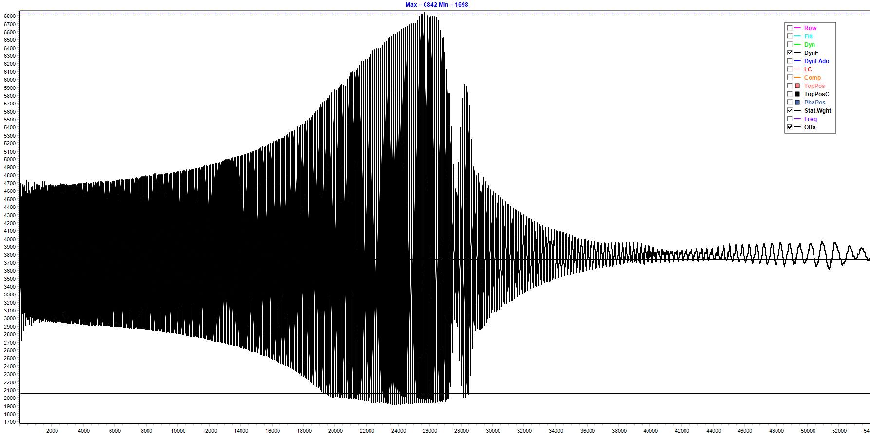
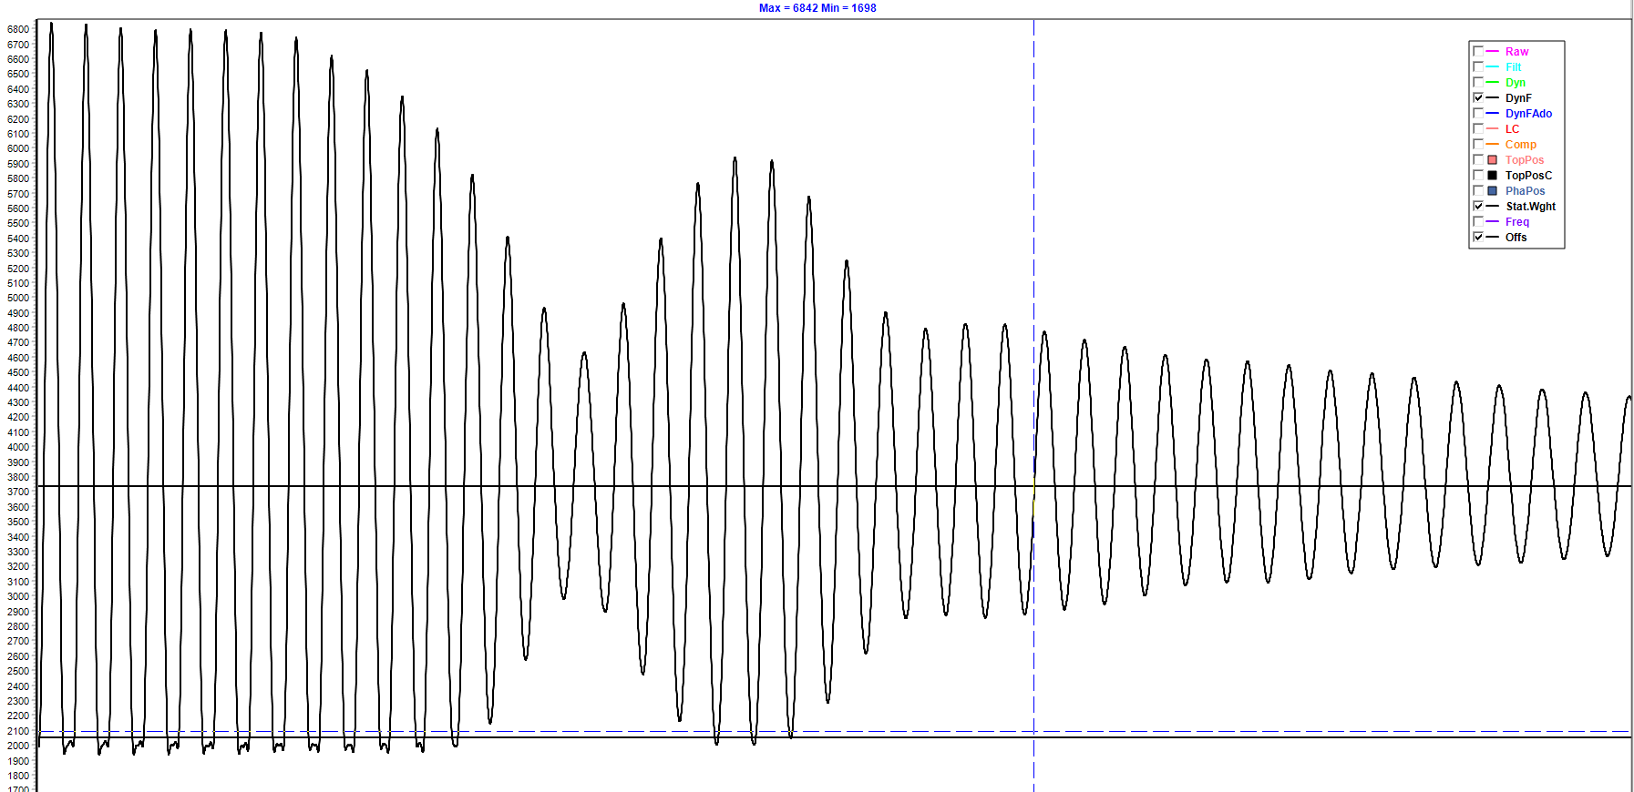
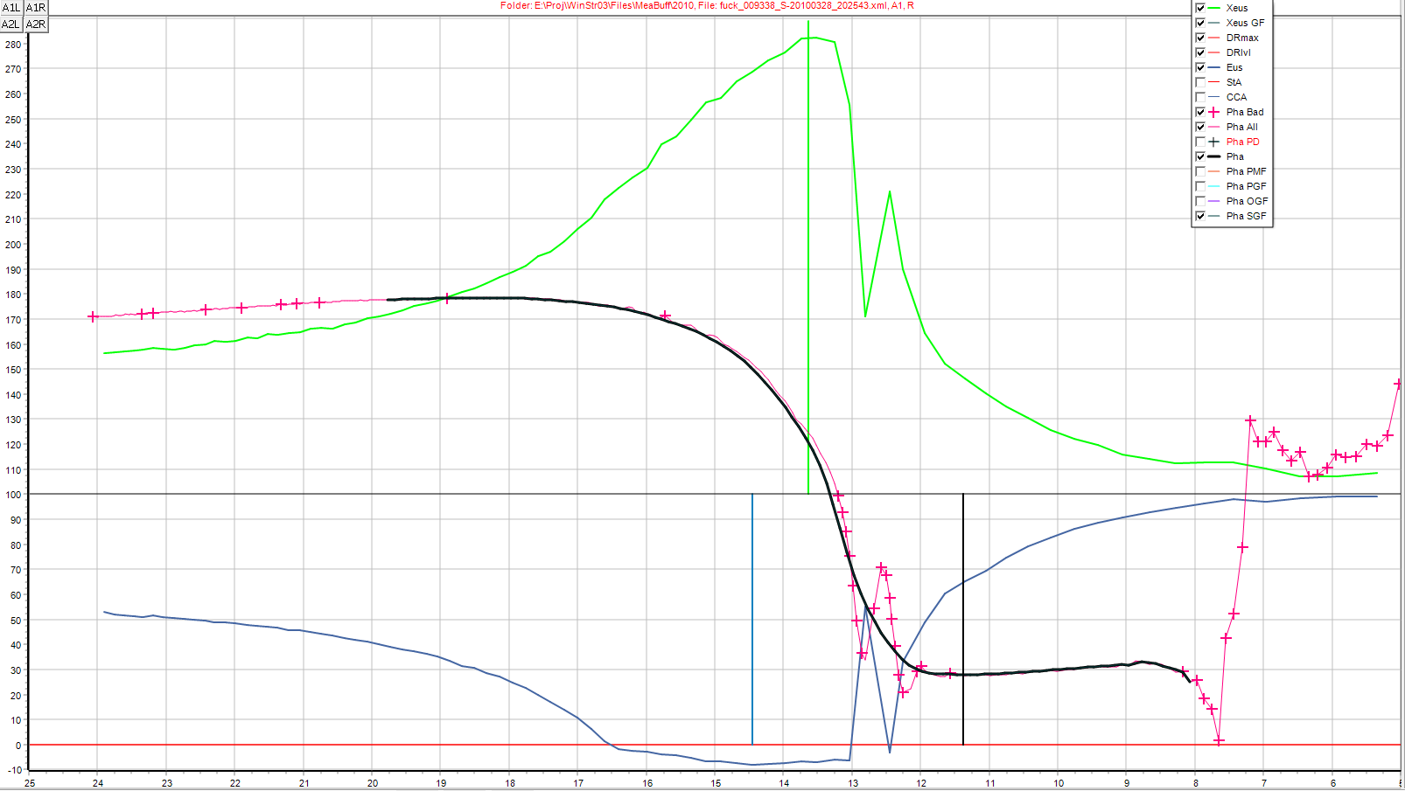
- Subclause title
- Subclause title
- Subclause title
- Subclause title
Text of the annex.
- (informative)
Relationship between this European Standard and the [essential]/[interoperability]/[…] requirements of [Directive]/[Regulation]/[Decision]/[…][Reference numbers of the legal act] aimed to be covered
[NOTE to the drafter: This is the Generic Annex ZA template. For some Directives/Regulations, specific templates need to be used and these can be found on the CEN BOSS: https://boss.cen.eu/reference%20material/FormsTemplates/Pages/default.aspx]
This European Standard has been prepared under a Commission’s standardization request [Full reference to the request “M/xxx”/”C(2015) xxxx final”] to provide one voluntary means of conforming to [essential] / [interoperability] / […] requirements of [Directive] / [Regulation] / [Decision] / […] [Reference numbers of the legal act] [Full title].
Once this standard is cited in the Official Journal of the European Union under that [Directive] / [Regulation] / [Decision] / […], compliance with the normative clauses of this standard given in Table […] confers, within the limits of the scope of this standard, a presumption of conformity with the corresponding [essential] / [interoperability] / […] requirements of that [Directive] / [Regulation] / [Decision] / […], and associated EFTA regulations.

Table ZA.1 — Correspondence between this European Standard and [Annex … of] / [Article(s) … of] [Directive] / [Regulation] / [Decision] [Reference numbers of the legal Act]]
[Essential]/ [interoperability]/[…] Requirements of [Directive]/[Regulation]/[Decision] [ …] | Clause(s)/sub-clause(s) of this EN | Remarks/Notes
[NOTE to the drafter, to be removed before publication:
This table can be used to accommodate all possible cases and independently how detailed correspondence is established or is possible to give:
- to declare the correspondence with a general statement ‘all requirements are covered’ by complying ‘all (or indicated) clauses’ (then the table would contain only one row);
- to declare more detailed correspondence (then the table would contain as many rows as needed).]
WARNING 1 — Presumption of conformity stays valid only as long as a reference to this European Standard is maintained in the list published in the Official Journal of the European Union. Users of this standard should consult frequently the latest list published in the Official Journal of the European Union.
WARNING 2 — Other Union legislation may be applicable to the product(s) / [service(s)] / […] falling within the scope of this standard.

Bibliography
[1] Avner I.E.D., Keijzer J.H., van Norden G.A.G. (European Shock Absorber Manufacturers’ Association), Suspension performance testing, IMechE 1976 Automotive Engineer, Augustus/September 1976;

[2] Balsarotti S. & Bradley W., Experimental Evaluation of a Non-Instrusive Automotive Suspension Testing Apparatus , SAE Technical Paper Series SAE 2000-01-1329, Hunter Engineering Co. & General Motors Corp., 2000;

[3] Calvo J.A., Diaz V., San Roman J.L., Etablishing inspection criteria to verify the dynamic behaviour of the vehicle suspension system by a platform vibrating test bench. , E.P.S. Carlos III University of Madrid, Department of Mechanical Engineering, Inderscience Enterprises Ltd, Int. J. Vehicle Design, Vol.38, No. 4, 2005;

[4] EUSAMA, Recommendation for performance test specification of « On car vehicle suspension testing system », EUSAMA-TS-02-76, 1976;

[5] Tsymberov A., An improved Non-Instrusive Automotive Suspension Testing Apparatus with Means to Determine the Condition of a Dampers. , SAE Technical Paper Series SAE 960735, Hunter Engineering Co.; 1996

