Asanetwork proposal - Rev2017 10 11

According to the information received from the latest EGEA Board meeting, the shareholders of asanetwork GmbH made the following final decisions:

- Asanetwork shareholders:
- Beginning from January 1, 2018, asanetwork GmbH will open up to new shareholders from the garage equipment / automotive software sectors in Germany as well as abroad (EU).
- Every new shareholder shall be allowed to acquire a maximum of 10 shares of € 2,600 each. On the whole, a maximum of 100 shares will be issued.
- Every shareholder will have one vote only irrespective of the number of shares he owns. However, dividends shall be paid based on the number of shares a shareholder owns.

- Technical Committee:
- The German Technical Committee of asanetwork and the EGEA Working Group 10 (Network) will cease their existence. A new EGEA-Net Technical Committee (TC) will be created. At least two thirds of the members of the EGEA-Net TC will be representatives of companies under the EGEA umbrella. The EGEA-Net TC will elect a chairman and a deputy chairman.
- The Working Group shall perform consultative tasks and be responsible for technical subjects only. The Working Group shall have complete autonomony in further defining the network standard and technical requirements. Proposals concerning asanetwork product developments will have to be authorised by the management and the shareholders of asanetwork GmbH.
On daily operational business procedures, the managing director(s) decide on customization of asanetwork – software – products. These do not affect the content of the standard and are paid by the customers.

- Asanetwork interface:
- The interface of asanetwork will be disclosed (released) and hence the protocol specifications can be ordered at a handling fee of € 100 (updates of € 50 each).
- The above said fee cannot be changed unilaterally by asanetwork.
- In case asanetwork becomes unable to maintain and distribute the interface specification, their ownership will be transferred to EGEA

- Network manager specifications:
- The specifications of the network manager will also be disclosed and hence can be acquired at a fee of € 5,000 (updates of € 500 each).
- The above said fee cannot be changed unilaterally by asanetwork.
- In case asanetwork becomes unable to maintain and distribute the network manager specification, their ownership will be transferred to EGEA

- Asanetwork customers - Subscription fee:
- The former licence fee of € 8,700 as well as the update fee of € 1,900 will be omitted from January 1, 2018. In the future, all customers of asanetwork (currently called “participants”) will pay a subscription fee of € 2,500 p.a. The subscription fee will be used to maintain and develop the network software and tools.
- The subscription fee shall entitle the members to receive the latest software updates as well as a diagnostics software.
- The above said fee will not apply to implementers who decide to buy only the interface specifications and not to use the asanetwork software and tools.

- Certification:
- In the future, all implementers of the network standard can apply for certification of the interface of their equipment / software by AxoNet, a notified body or other certification authorities nominated by the EGEA members and approved by EGEA. Certification fees will be approx. € 1.500 per product group / software;
- EGEA will charge approx. € 500 for the release of the EGEA label. Exact initial and renewal costs for the EGEA label are to be defined at a later stage.
- Once certified the companies will receive the ”EGEA certified“ label.
- The list of notified bodies is available on the European Commission website: http://ec.europa.eu/growth/tools-databases/nando/index.cfm?fuseaction=search.main

- Network product information:

- A network comprises of the following three components:

- Network-compatible equipment
- Network-compatible software (DMS / PTI software)
- The network manager (netman) which organises data flow between equipment and software.

The netman is presently sold to end users (garages) at € 829. Resellers (wholesalers) are granted a resale discount.
Updates can be downloaded free of charge from the internet.

At present, approx. 80 companies from Germany and abroad participate in the asanetwork standard. In addition to the interface specification, asanetwork offers development tools (royalty) for programming of the interface as well as the network manager asanetman

Parties interested in acquiring shares will receive the attached letter. Before a shareholder contract is signed, a non-disclosure agreement (attached) must be signed. With the non-disclosure agreement parties interested can also receive the balance sheets and the EBIT of the past three years if interested.

Facts and figures:

- Annual turnover of approx. 250,000 euros
- No significant tangible assets, interface software
- No liabilities (payables)
- No extraordinary receivables
- No balance-sheet risk

asanetwork goes Europe

asanetwork was founded in 1998. At the moment asanetwork GmbH has 13 shareholders. The amount of one share is € 2.600. Maximum shares per shareholder are 10 shares, whereas the maximum of shares is limited to 100 in total.

Each shareholder has one vote, no matter how many shares he owns. Profit will be split by share ratio, maximum 10 shares per shareholder in the future.

Shareholders decide about cost and profit structure of the future ”network company” and further product developments.

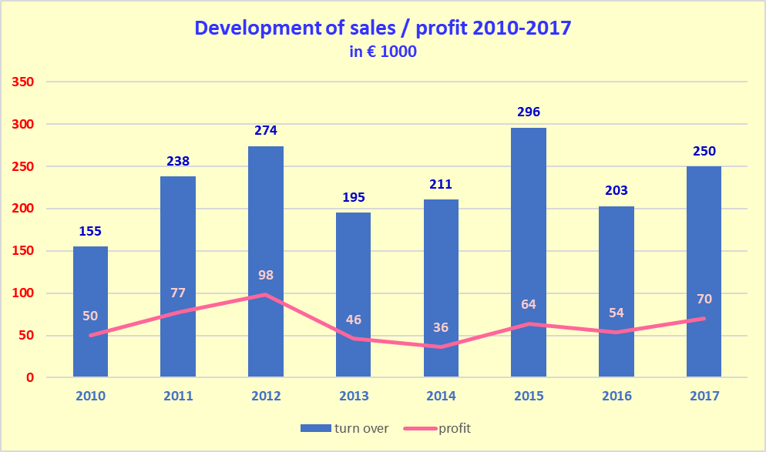
fore-
cast

Sales / profit figures are mainly made in Germany. So, we believe there is a great potential in Europe for car dealers, independent repair shops and PTI.

asanetwork has approx. 80 network participants holding a licence (see attached list). At the moment, we have approx. 7.000 installations in Europe, mainly in Germany.

Advantage for the automotive aftermarket:

Support of only one network standard for repair shops and PTI in Europe means less programming costs and less man power for every equipment- and software manufacturer, optimisation of the repair shop management, cost savings for the repair shops up to € 50,000 p.a.

Our present business concept:

If an equipment manufacturer, software producer or PTI organisation wants to implement the asanetwork interface, he must buy a one-time licence at € 8.700 euros. For the licence fee, he receives the asanetwork software. On top, he must pay an update fee of € 1.900 a year. We also request software certification to make sure that asanetwork is correctly programmed. The certification fee is approx. € 800 depending on work involved. This procedure will change in 2018 according to the agreement we made with EGEA.

Since the car dealer / repair shop or PTI shop has the biggest benefit of the interface, we created the asanetwork manager to organise the data flow between equipment and commercial software (DMS). This is a piece of software with a USB dongle for copy protection. One-time fee for end user (garages) is € 829, updates are available free of charge as download from the internet.

The future business concept we explained above will finally be decided in detail by the shareholders of the “European” company together with the members of the EGEA.

List of shareholders

No of Shares Total amount

AHS Prüftechnik 1 € 2,600
Beissbarth 10 € 26,000
Bodi Data 2 € 5,200
Continental Aftermarket 2 € 5,200
Frank 1 € 2,600
HEKA 1 € 2,600
Hella Gutmann 2 € 5,200
Loco Soft 1 € 2,600
Longus 1 € 2,600
MAHA 10 € 26,000
Saxon Junkalor 1 € 2,600
Saxon Prüftechnik 2 € 5,200
Snap-on 10 € 26,000
____________________________________

Total 44 € 114,000

