Dear Eléonore,

According to the information received from the latest EGEA Board meeting, the shareholders of asanetwork GmbH made the following final decisions:

- Beginning from January 1, 2018, asanetwork GmbH will open up to new shareholders from the garage equipment / automotive software sectors in Germany as well as abroad (EGEA).

Every new share holders shall be allowed to acquire a maximum of 10 shares of € 2,600 each. On the whole, a maximum of 100 shares will be issued.

Every share holder will have one vote only irrespective of the number of shares he owns. However, dividends shall be paid based on the number of shares a shareholder owns.

- The German Technical Committee of asanetwork will merge with EGEA Working Group 10 (Network) which will than act as Technical Committee. The members of the European Working Group will elect a chairman and a deputy chairman.

The Working Group shall perform consultative tasks and be responsible for technical subjects only. Proposals and product developments will have to be authorised by the management and the shareholders of asanetwork GmbH respectively.

- The interface of asanetwork will be disclosed (released) and hence can be ordered at a handling fee of 100 euros (updates of 50 euros each).

- The specifications of the network manager will also be disclosed and hence can be acquired at a fee of € 5.000 (updates of € 500 each).

- The former licence fee of € 8.700 as well as the update fee of € 1.900 will be omitted from January 1, 2018. In the future, all members to the network will pay a royalty of € 2,5000 p.a. The royalty will be used to maintain and develop the network standard.

The royalty shall entitle the members to receive the latest update as well as a diagnostics software.

- In the future, all members of the network standard will have to apply for certification of the interface of their equipment / software by AxoNet or a similar institution. Certification fees will be approx. € 2.000 per product group / software; EGEA will receive € 500 of this fee.

- Once certified the companies will receive a sticker ”EGEA certified“.

- A network comprises of the following three components:

- Network-compatible equipment
- Network-compatible software (DMS / PTI software)
- The network manager (netman) which organises data flow between equipment and software.

The netman is presently sold to end users (garages) at € 829. Resellers (wholesalers) are granted a resale discount.
Updates can be downloaded free of charge from the internet.

At present, approx. 80 companies from Germany and abroad participate in the asanetwork standard. In addition to the interface specification, asanetwork offers development tools (royalty) for programming of the interface as well as the network manager asanetman

Parties interested in acquiring shares will receive the attached letter. Before a shareholder contract is signed, a non-disclosure agreement (attached) must be signed. With the non-disclosure agreement parties interested can also receive the balance sheets and the EBIT of the past three years if interested.

Facts and figures:

- Annual turnover of approx. 250,000 euros
- No significant tangible assets, interface software
- No liabilities (payables)
- No extraordinary receivables
- No balance-sheet risk

asanetwork goes Europe

asanetwork was founded in 1998. At the moment asanetwork GmbH has 13 shareholders. The amount of one share is € 2.600. Maximum shares per shareholder are 10 shares, whereas the maximum of shares is limited to 100 in total.

Each shareholder has one vote, no matter how many shares he owns. Profit will be split by share ratio, maximum 10 shares per shareholder in the future.

Shareholders decide about cost and profit structure of the future ”network company” and further product developments.

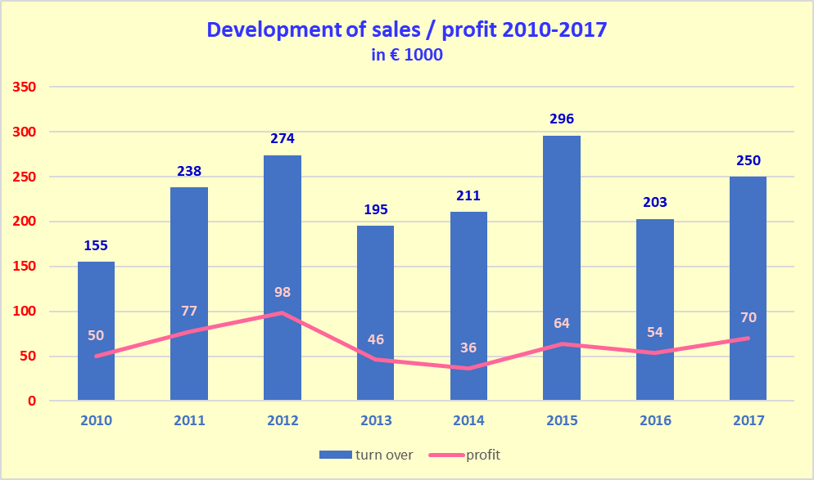
fore-
cast

Sales / profit figures are mainly made in Germany. So, we believe there is a great potential in Europe for car dealers, independent repair shops and PTI.

asanetwork has approx. 80 network participants holding a licence (see attached list). At the moment, we have approx. 7.000 installations in Europe, mainly in Germany.

Advantage for the automotive aftermarket:

Support of only one network standard for repair shops and PTI in Europe means less programming costs and less man power for every equipment- and software manufacturer, optimisation of the repair shop management, cost savings for the repair shops up to € 50,000 p.a.

Our present business concept:

If an equipment manufacturer, software producer or PTI organisation wants to implement the asanetwork interface, he must buy a one-time licence at € 8.700 euros. For the licence fee, he receives the asanetwork software. On top, he must pay an update fee of € 1.900 a year. We also request software certification to make sure that asanetwork is correctly programmed. The certification fee is approx. € 800 depending on work involved. This procedure will change in 2018 according to the agreement we made with EGEA.

Since the car dealer / repair shop or PTI shop has the biggest benefit of the interface, we created the asanetwork manager to organise the data flow between equipment and commercial software (DMS). This is a piece of software with a USB dongle for copy protection. One-time fee for end user (garages) is € 829, updates are available free of charge as download from the internet.

The future business concept we explained above will finally be decided in detail by the shareholders of the “European” company together with the members of the EGEA.

List of shareholders

No of Shares Total amount

AHS Prüftechnik 1 € 2,600
Beissbarth 10 € 26,000
Bodi Data 2 € 5,200
Continental Aftermarket 2 € 5,200
Frank 1 € 2,600
HEKA 1 € 2,600
Hella Gutmann 2 € 5,200
Loco Soft 1 € 2,600
Longus 1 € 2,600
MAHA 10 € 26,000
Saxon Junkalor 1 € 2,600
Saxon Prüftechnik 2 € 5,200
Snap-on 10 € 26,000
____________________________________

Total 44 € 114,000

